Digital Assignment 1

Database Management System

Name: Om Ashish Mishra

Registration Number: 16BCE0789

Slot: D1+TD1

The Questions:

1

create table STUDENT_DET (

ID_NUMBER varchar2(100),

LAST_NAME varchar2(100),

FIRST_NAME varchar2(100),

MID_INI varchar2(100),

SUFFIX varchar2(100),

ORA-00904: : invalid identifier

2

create table STUDENT_DET (

ID_NUMBER varchar2(100),

LAST_NAME varchar2(100),

FIRST_NAME varchar2(100),

MID_INI varchar2(100),

SUFFIX varchar2(10),

)

ORA-00904: : invalid identifier

3

create table STUDENT_DET (

ID_NUMBER varchar2(100),

LAST_NAME varchar2(100),

FIRST_NAME varchar2(100),

MID_INI varchar2(100),

SUFFIX varchar2(10),

)

ORA-00904: : invalid identifier

4

create table STUDENT_DET (

ID_NUMBER varchar2(100),

LAST_NAME varchar2(100),

FIRST_NAME varchar2(100),

MID_INI varchar2(100),

SUFFIX varchar2(10),

)

ORA-00904: : invalid identifier

7

create table STUDENT_DET (

ID_NUMBER varchar(100),

LAST_NAME varchar(100),

FIRST_NAME varchar(100),

MID_INI varchar(100),

SUFFIX varchar(10),

)

ORA-00904: : invalid identifier

11

create table STUDENT_DET (

ID_NUMBER varchar(100)NOT NULL PRIMARY KEY,

LAST_NAME varchar(100),

FIRST_NAME varchar(100),

MID_INI varchar(100),

SUFFIX varchar(10),

)

ORA-00904: : invalid identifier

12

create table STUDENT_DET (

ID_NUMBER varchar(100)NOT NULL PRIMARY KEY,

LAST_NAME varchar(100),

FIRST_NAME varchar(100),

MID_INI varchar(100),

SUFFIX varchar(10),

)

ORA-00904: : invalid identifier

13

create table STUDENT_DET (

ID_NUMBER varchar(100)NOT NULL PRIMARY KEY,

LAST_NAME varchar(100),

FIRST_NAME varchar(100),

MID_INI varchar(100),

SUFFIX varchar(10),

)

ORA-00904: : invalid identifier

14

create table STUDENT_DET (

ID_NUMBER varchar(20),LAST_NAME varchar(20),

FIRST_NAME varchar(20),

MID_INI varchar(10),SUFFIX varchar(10))

Table created.

15

create table STUDENT_DET (

ID_NUMBER varchar(20),LAST_NAME varchar(20),

FIRST_NAME varchar(20),

MID_INI varchar(10),SUFFIX varchar(10))

ORA-00955: name is already used by an existing object

18

create table STUDENT_DET (

ID_NUMBER varchar(20),LAST_NAME varchar(20),

FIRST_NAME varchar(20),

MID_INI varchar(10),SUFFIX varchar(10))

ORA-00955: name is already used by an existing object

Similar Question: 26,54

The Answers:

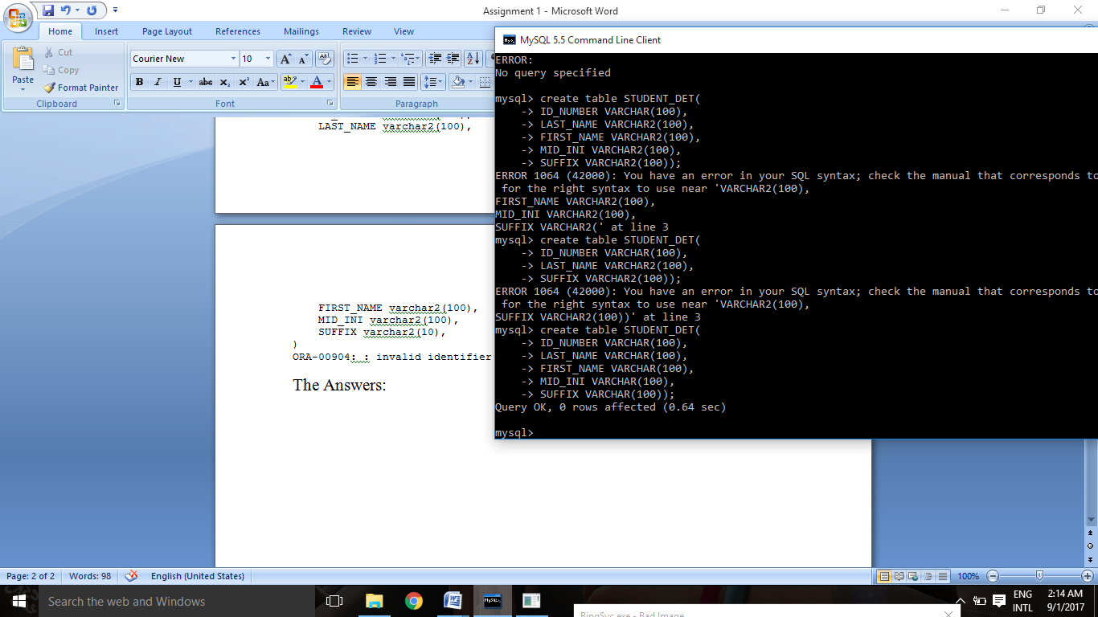

5

insert into STUDENT_DET values ('16-12256-663','ALBERCA','KHARLA MEI',D','')

ORA-01756: quoted string not properly terminated

9

insert into STUDENT_DET values ('16-12256-663','ALBERCA','KHARLA MEI',D','')

ORA-01756: quoted string not properly terminated

16

insert into STUDENT_DET values ('16-12256-663','ALBERCA','KHARLA MEI',D','')

ORA-01756: quoted string not properly terminated

19

insert into STUDENT_DET values ('16-12256-663','ALBERCA','KHARLA MEI',D',')

ORA-00917: missing comma

22

insert into STUDENT_DET values ('16-12256-663','ALBERCA','KHARLA MEI',D','')

ORA-01756: quoted string not properly terminated

24

insert into STUDENT_DET values ('16-12256-663','ALBERCA','KHARLA MEI',D','')

ORA-01756: quoted string not properly terminated

19

insert into STUDENT_DET values ('16-12256-663','ALBERCA','KHARLA MEI',D',')

ORA-00917: missing comma

Similar Question: 27,29,34,36,39,40,43,49,55,102

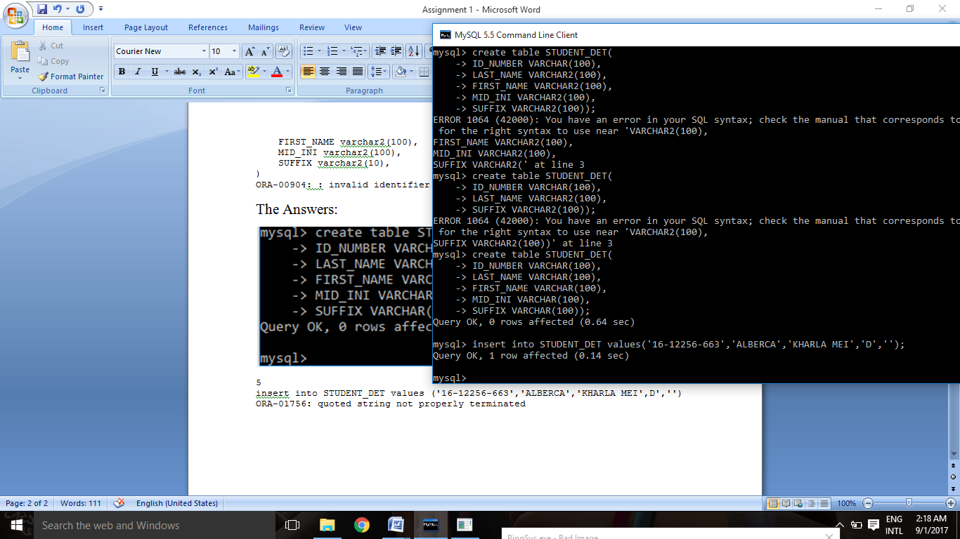

6

select * from STUDENT_DET

where id_number like '16%'

ORA-00942: table or view does not exist

10

select * from STUDENT_DET

where id_number like '16%'

ORA-00942: table or view does not exist

17

select * from STUDENT_DET

where id_number like '16%'

no data found

Similar Question: 25,28,30,33,37,38

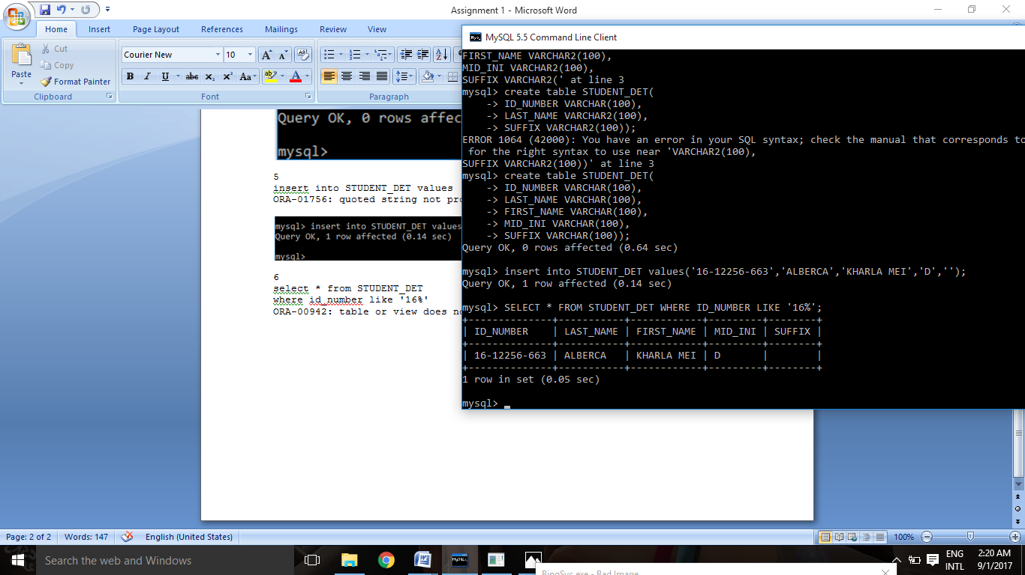

23

select * from STUDENT_DET

no data found

Similar Question: 35,41,76

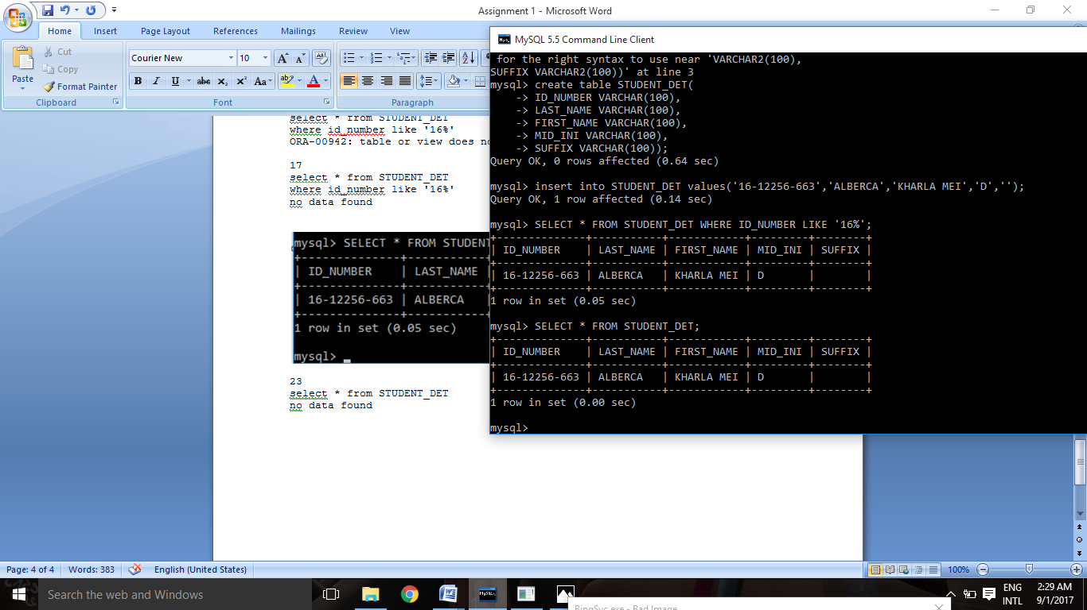

31

create table STUDENT_DET2 (

ID_NUMBER varchar(20),LAST_NAME varchar(20),

FIRST_NAME varchar(20),

MID_INI varchar(10),SUFFIX varchar(10)

)

Table created.

Similar Question: 42,48,54

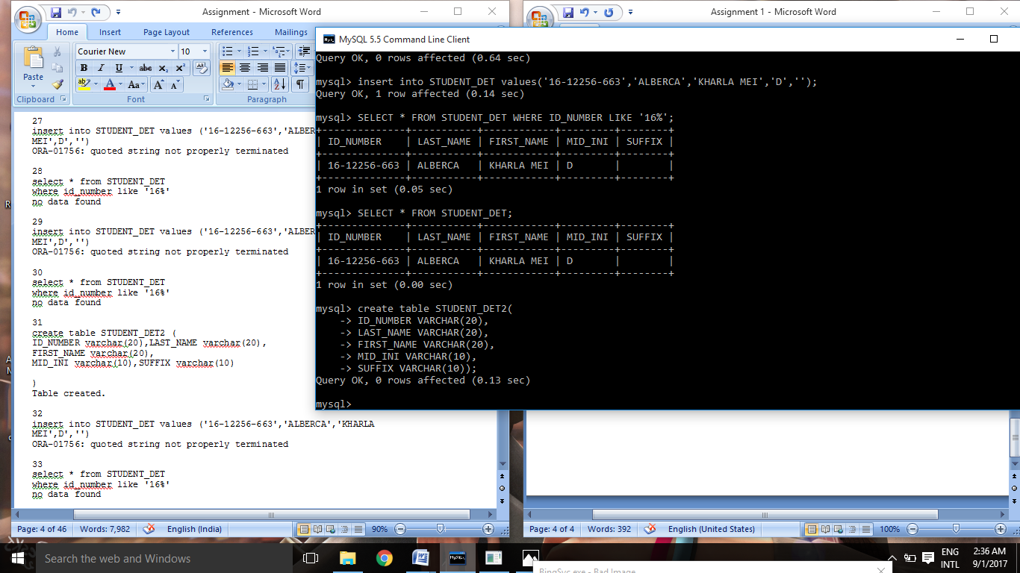

44

insert into STUDENT_DET values ('14-15630-227','ALVAREZ','MARVYN','L','')

1 row(s) inserted.

Similar Question: 50,56,87,103

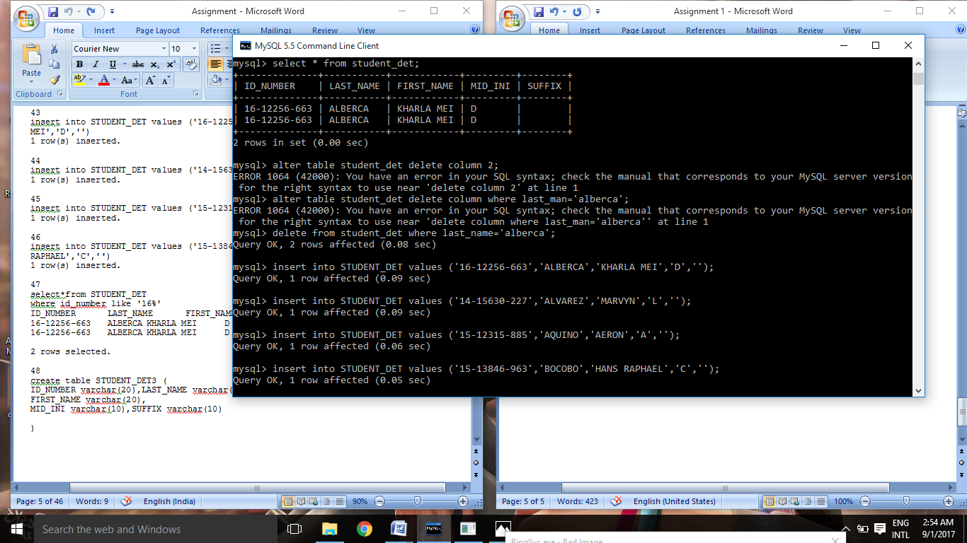

45

insert into STUDENT_DET values ('15-12315-885','AQUINO','AERON','A','')

1 row(s) inserted.

Similar Question: 51,57,88,104

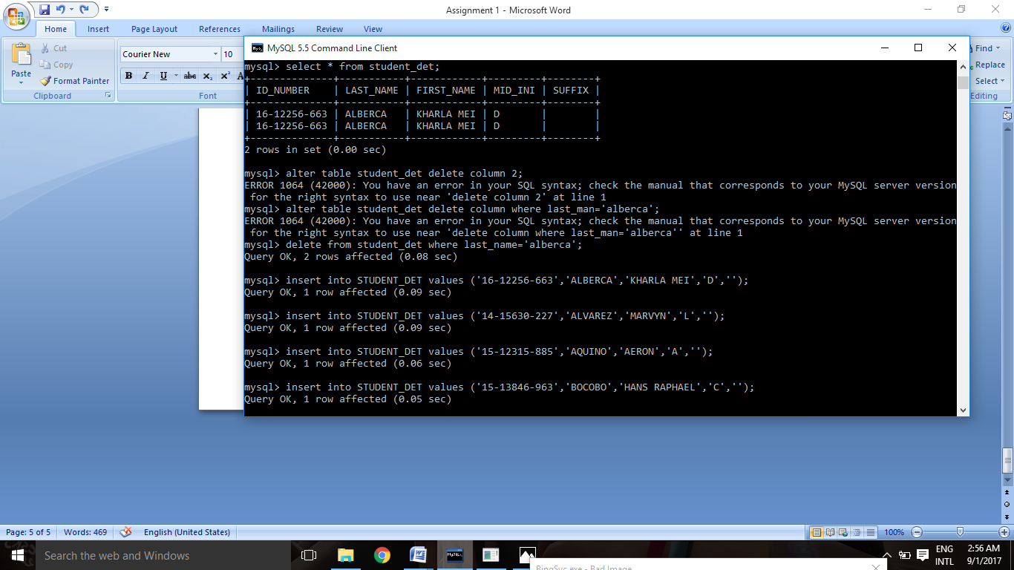

46

insert into STUDENT_DET values ('15-13846-963','BOCOBO','HANS RAPHAEL','C','')

1 row(s) inserted.

Similar Question: 52,58,89,105



47

select*from STUDENT_DET

where id_number like '16%'

ID_NUMBER LAST_NAME FIRST_NAME MID_INI SUFFIX

16-12256-663 ALBERCA KHARLA MEI D -

16-12256-663 ALBERCA KHARLA MEI D -

2 rows selected.

Similar Question: 53,59



60

select*from STUDENT_DET

where last_name like 'A'

no data found

Similar Question: 61,62,63,64,65,66,67,68

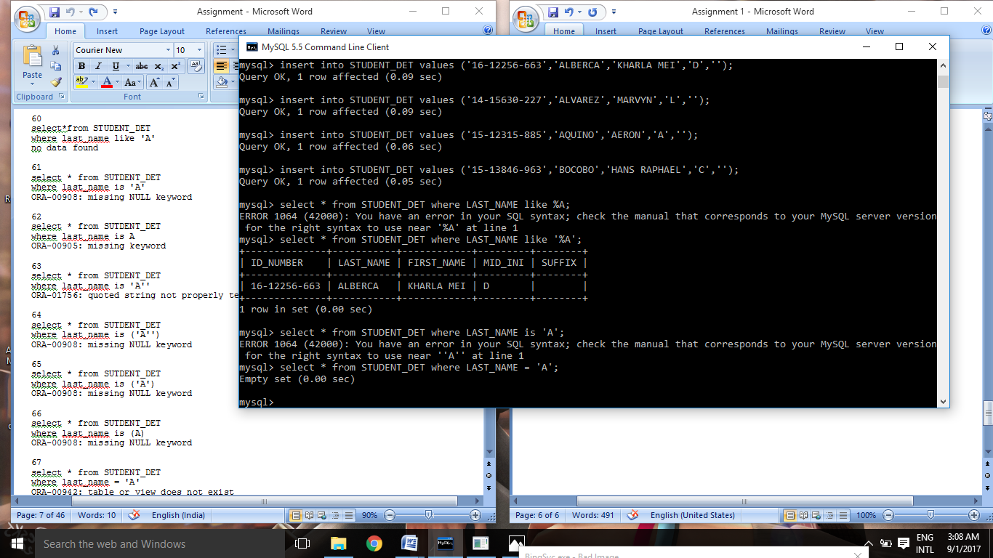

69

select * from STUDENT_DET

where last_name = '%A'

no data found

Similar Question: 70

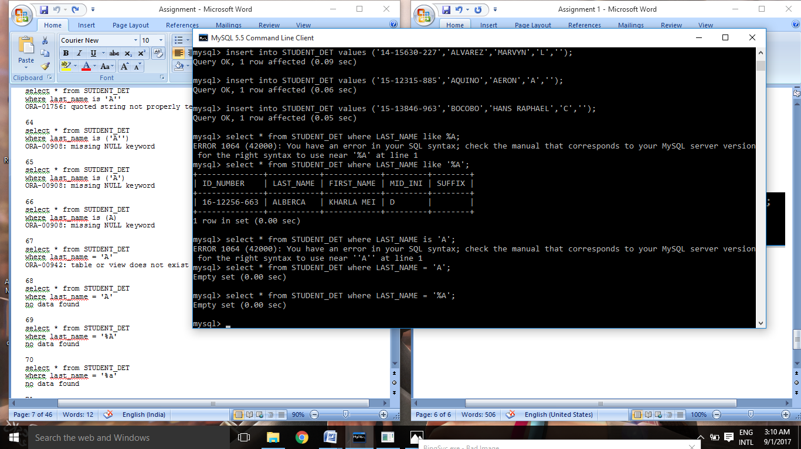

72

select * from STUDENT_DET

where last_name LIKE '%A'

ID_NUMBER LAST_NAME FIRST_NAME MID_INI SUFFIX

16-12256-663 ALBERCA KHARLA MEI D -

Similar Question: 71

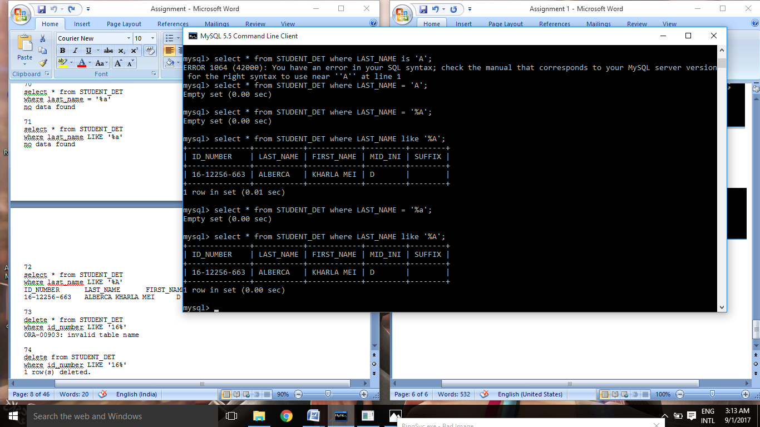

73

delete * from STUDENT_DET

where id_number LIKE '16%'

ORA-00903: invalid table name

74

delete from STUDENT_DET

where id_number LIKE '16%'

1 row(s) deleted.

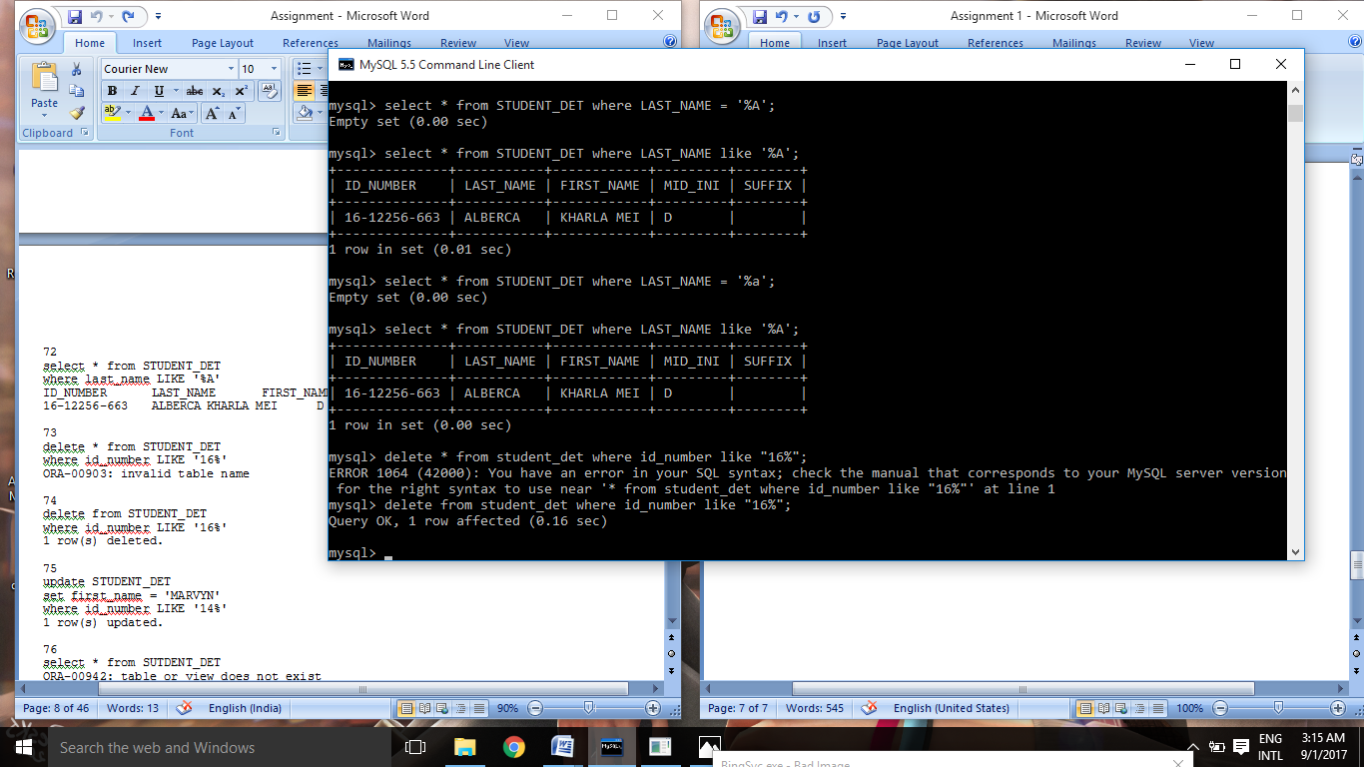

75

update STUDENT_DET

set first_name = 'MARVYN'

where id_number LIKE '14%'

1 row(s) updated.

Similar Question: 80

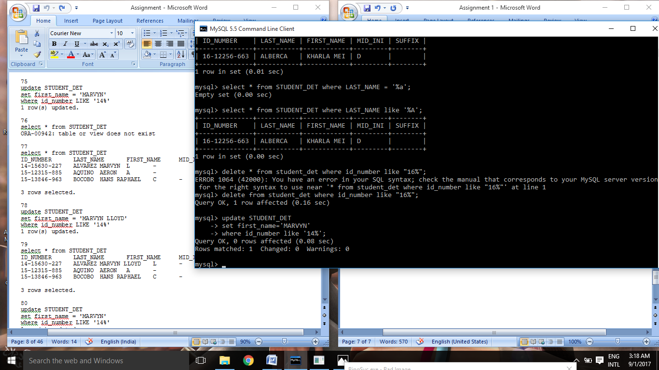

77

select * from STUDENT_DET

ID_NUMBER LAST_NAME FIRST_NAME MID_INI SUFFIX

14-15630-227 ALVAREZ MARVYN L -

15-12315-885 AQUINO AERON A -

15-13846-963 BOCOBO HANS RAPHAEL C -

3 rows selected.

Similar Question: 81

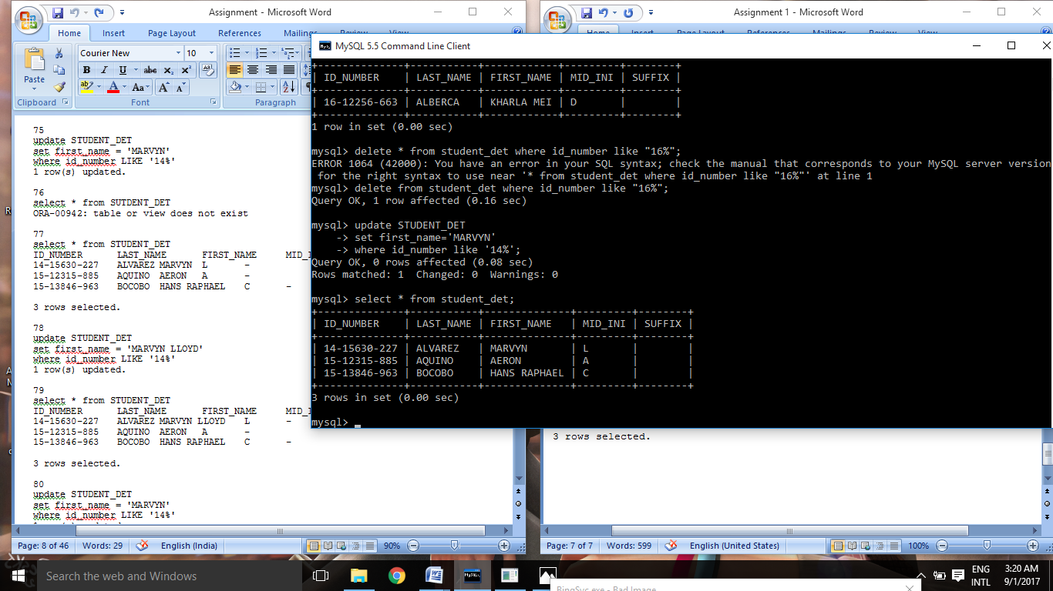

78

update STUDENT_DET

set first_name = 'MARVYN LLOYD'

where id_number LIKE '14%'

1 row(s) updated.

Similar Question: 82

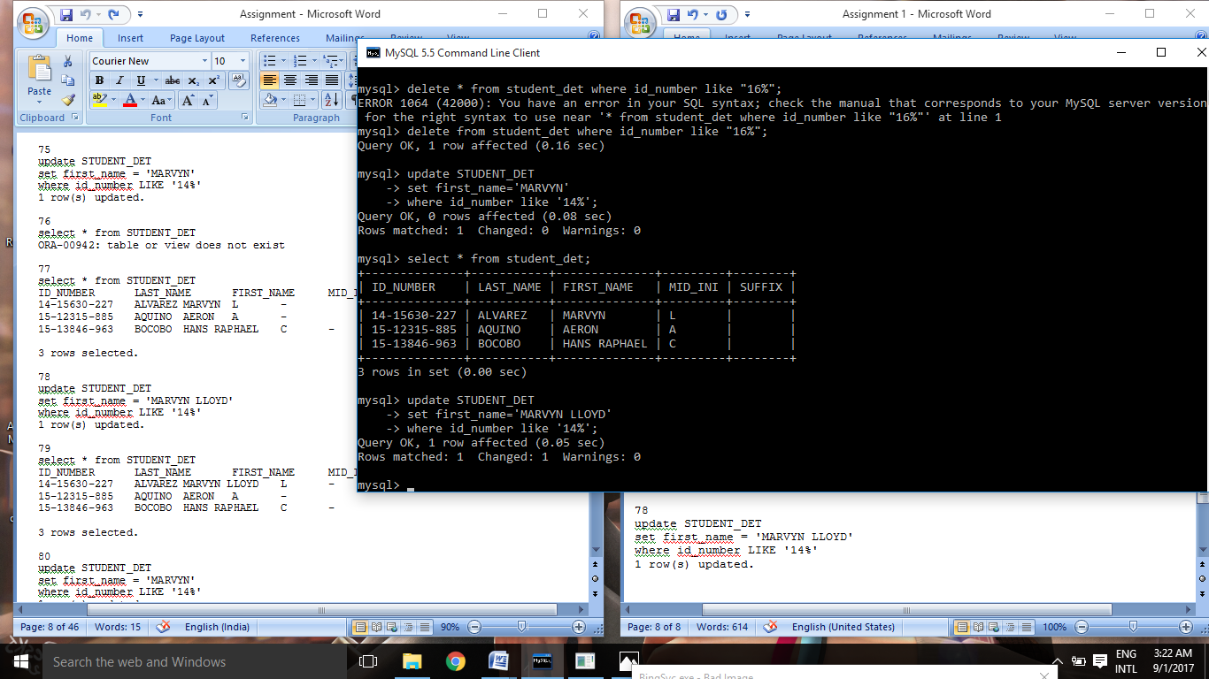

79

select * from STUDENT_DET

ID_NUMBER LAST_NAME FIRST_NAME MID_INI SUFFIX

14-15630-227 ALVAREZ MARVYN LLOYD L -

15-12315-885 AQUINO AERON A -

15-13846-963 BOCOBO HANS RAPHAEL C -

3 rows selected.

Similar Question: 83

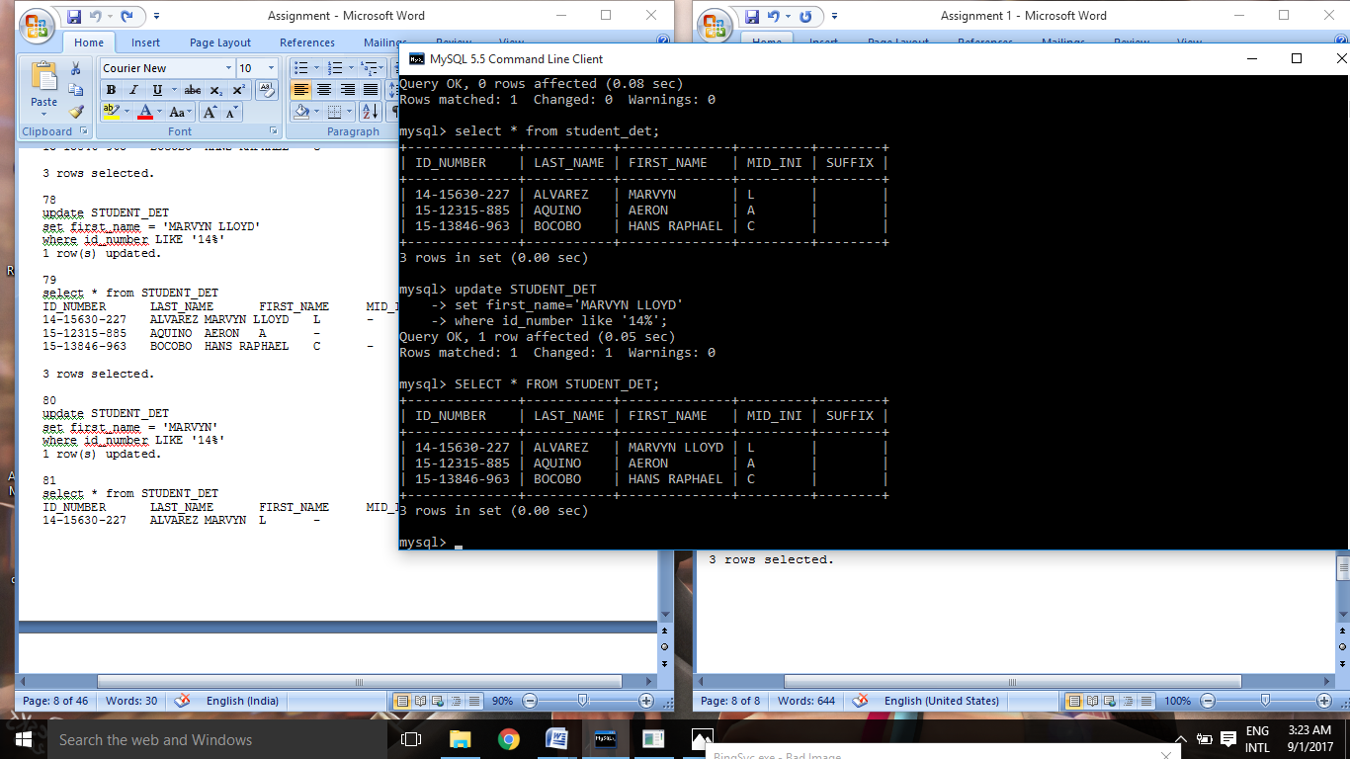

84

truncate table STUDENT_DET

Table truncated.

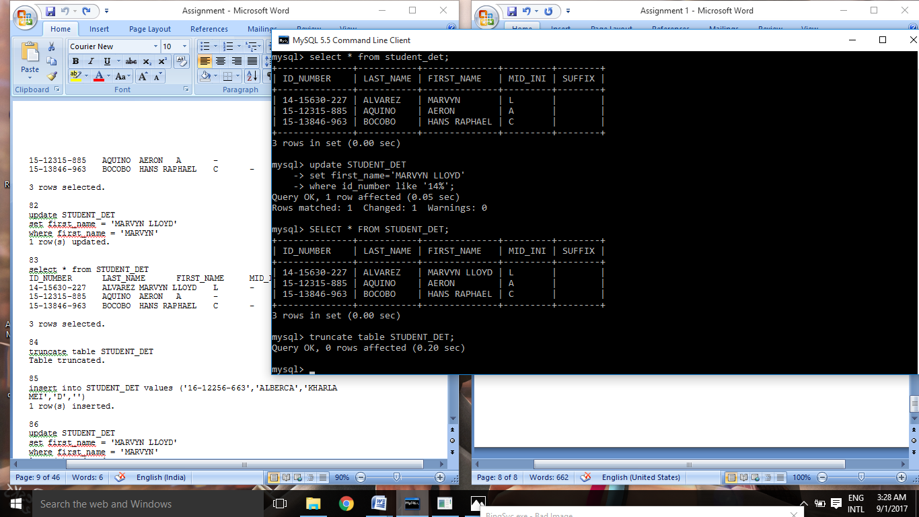

85

insert into STUDENT_DET values ('16-12256-663','ALBERCA','KHARLA MEI','D','')

1 row(s) inserted.

(AFTER TRUNCATING)



86

update STUDENT_DET

set first_name = 'MARVYN LLOYD'

where first_name = 'MARVYN'

1 row(s) updated.

(AFTER TRUNCATING)

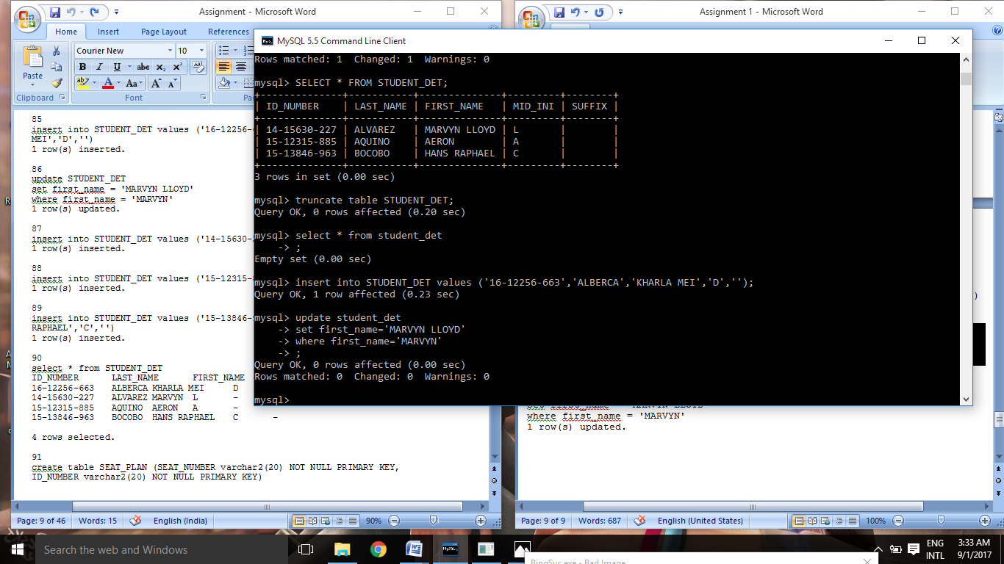

90

select * from STUDENT_DET

ID_NUMBER LAST_NAME FIRST_NAME MID_INI SUFFIX

16-12256-663 ALBERCA KHARLA MEI D -

14-15630-227 ALVAREZ MARVYN L -

15-12315-885 AQUINO AERON A -

15-13846-963 BOCOBO HANS RAPHAEL C -

4 rows selected.

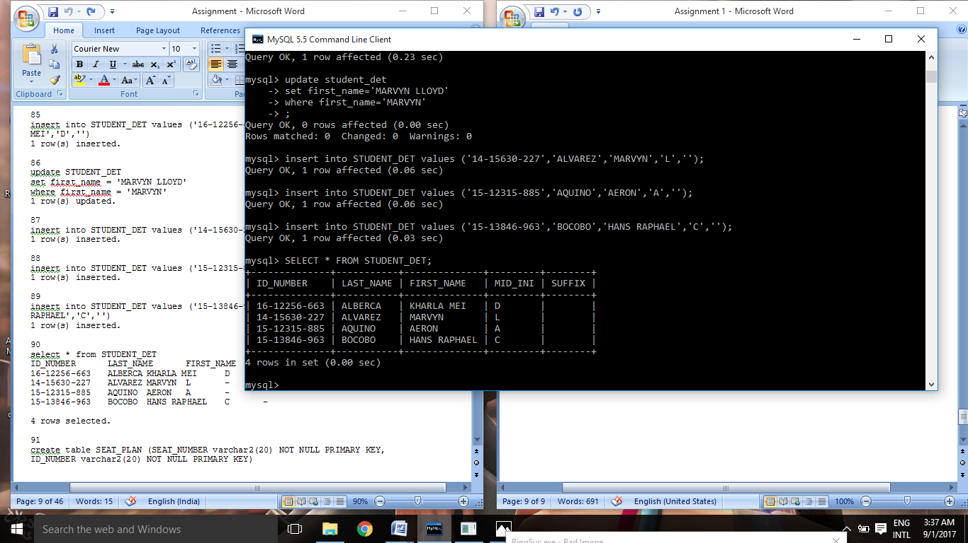

91

create table SEAT_PLAN (SEAT_NUMBER varchar2(20) NOT NULL PRIMARY KEY, ID_NUMBER varchar2(20) NOT NULL PRIMARY KEY)

ORA-02260: table can have only one primary key

Similar Question: 92,93,94

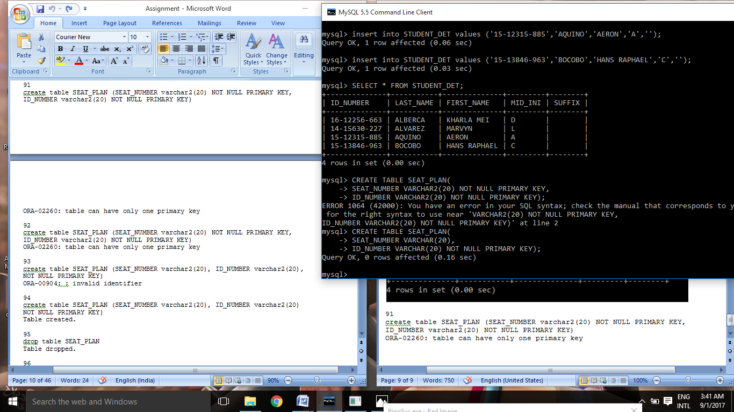

95

drop table SEAT_PLAN

Table dropped.

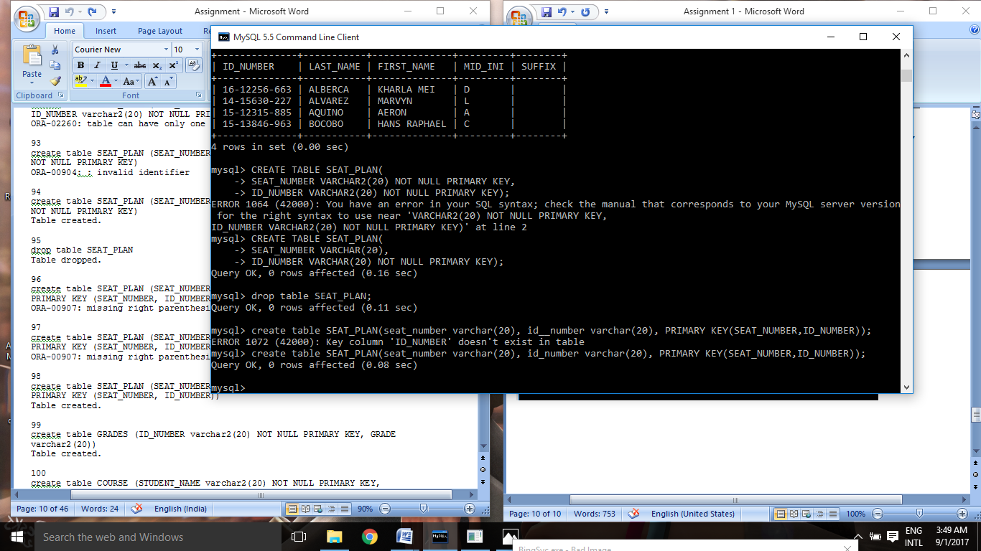

96

create table SEAT_PLAN (SEAT_NUMBER varchar2(20), ID_NUMBER varchar2(20) PRIMARY KEY (SEAT_NUMBER, ID_NUMBER)

ORA-00907: missing right parenthesis

Similar Question: 97,98,405



99

create table GRADES (ID_NUMBER varchar2(20) NOT NULL PRIMARY KEY, GRADE varchar2(20))

Table created.

Similar Question: 406

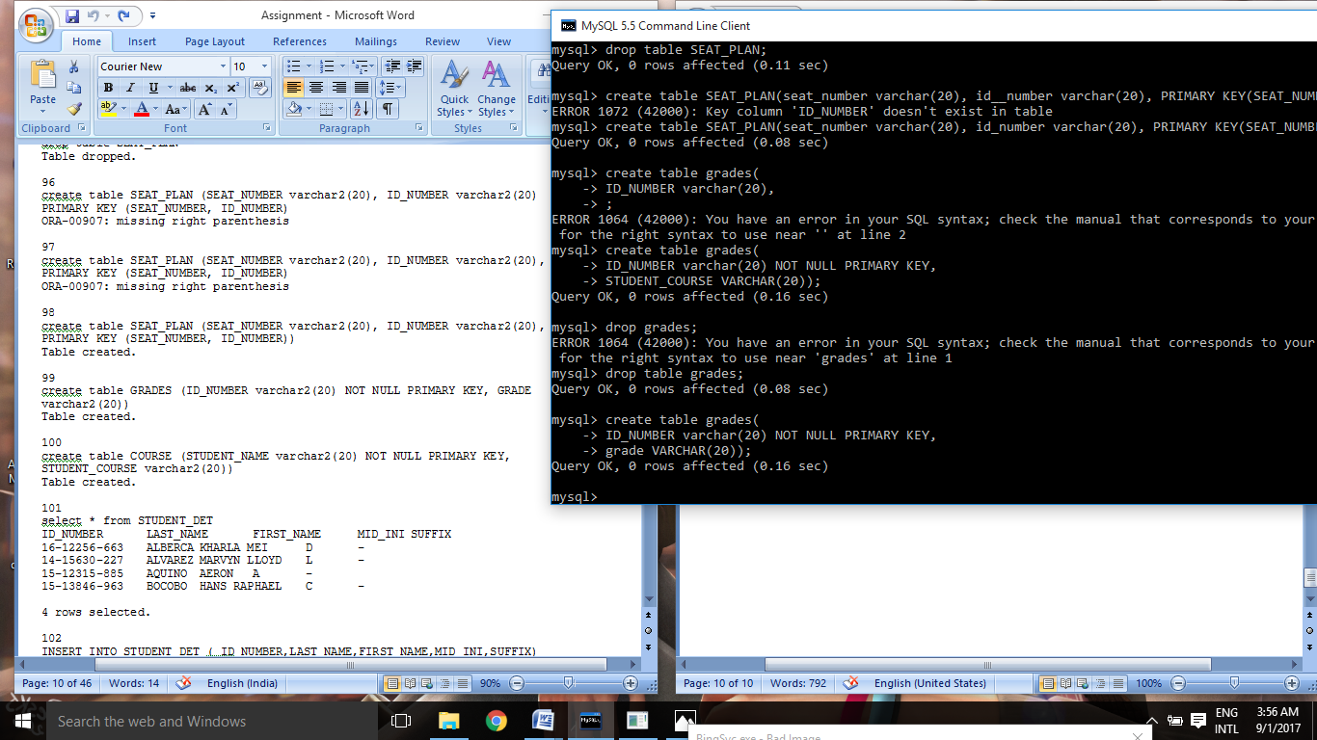

100

create table COURSE (STUDENT_NAME varchar2(20) NOT NULL PRIMARY KEY, STUDENT_COURSE varchar2(20))

Table created.

Similar Question: 407

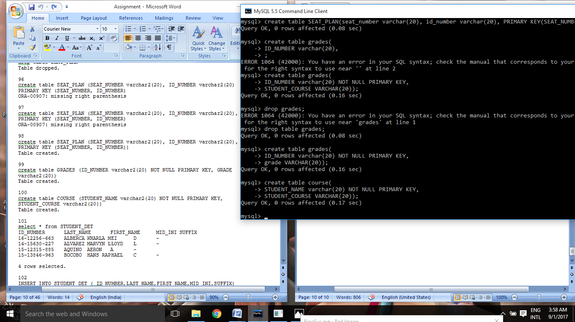

101

select * from STUDENT_DET

ID_NUMBER LAST_NAME FIRST_NAME MID_INI SUFFIX

16-12256-663 ALBERCA KHARLA MEI D -

14-15630-227 ALVAREZ MARVYN LLOYD L -

15-12315-885 AQUINO AERON A -

15-13846-963 BOCOBO HANS RAPHAEL C -

4 rows selected.

(After truncating and adding)

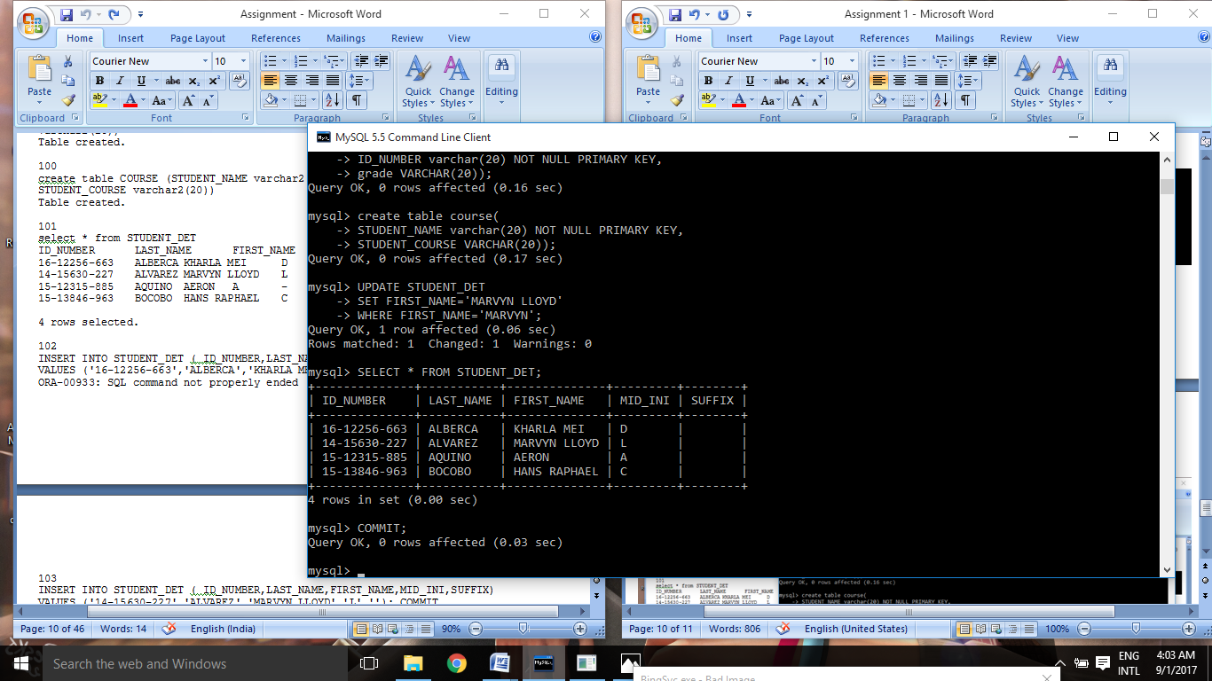

106

INSERT INTO STUDENT_DET ( ID_NUMBER,LAST_NAME,FIRST_NAME,MID_INI,SUFFIX) VALUES ('14-15194-524','CABALLERO','ARTHUR ROBERT','B',''); COMMIT

ORA-00933: SQL command not properly ended

107

INSERT INTO STUDENT_DET ( ID_NUMBER,LAST_NAME,FIRST_NAME,MID_INI,SUFFIX) VALUES ('1312405','CAMPOS','JEFFERSON','C',''); COMMIT

ORA-00933: SQL command not properly ended

108

INSERT INTO STUDENT_DET ( ID_NUMBER,LAST_NAME,FIRST_NAME,MID_INI,SUFFIX) VALUES ('16-13787-292','CARMESIS','ADRIAN','B',''); COMMIT

ORA-00933: SQL command not properly ended

109

INSERT INTO STUDENT_DET ( ID_NUMBER,LAST_NAME,FIRST_NAME,MID_INI,SUFFIX) VALUES ('14-11840-747','COMETA','MARIA LOURDES','E',''); COMMIT

ORA-00933: SQL command not properly ended

110

INSERT INTO STUDENT_DET ( ID_NUMBER,LAST_NAME,FIRST_NAME,MID_INI,SUFFIX) VALUES ('15-15994-487','DELA PEÑA','JEG','D',''); COMMIT

ORA-00933: SQL command not properly ended

111

INSERT INTO STUDENT_DET ( ID_NUMBER,LAST_NAME,FIRST_NAME,MID_INI,SUFFIX) VALUES ('14-13152-704','DUCANES','MARK JOSEPH','B',''); COMMIT

ORA-00933: SQL command not properly ended

112

INSERT INTO STUDENT_DET ( ID_NUMBER,LAST_NAME,FIRST_NAME,MID_INI,SUFFIX) VALUES ('14-11432-203','EDELEON','NEIL PATRICK','P',''); COMMIT

ORA-00933: SQL command not properly ended

113

INSERT INTO STUDENT_DET ( ID_NUMBER,LAST_NAME,FIRST_NAME,MID_INI,SUFFIX) VALUES ('14-14069-986','FIGUEROA','KHAIR','M',''); COMMIT

ORA-00933: SQL command not properly ended

114

INSERT INTO STUDENT_DET ( ID_NUMBER,LAST_NAME,FIRST_NAME,MID_INI,SUFFIX) VALUES ('16-12720-831','GACER','KUEANO JHON','E',''); COMMIT

ORA-00933: SQL command not properly ended

The Answers:

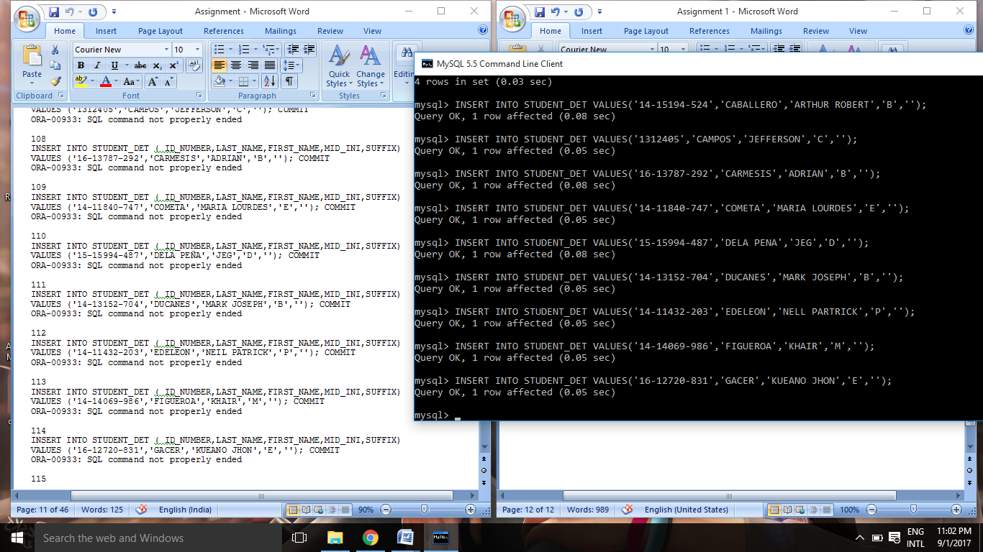

115

INSERT INTO STUDENT_DET ( ID_NUMBER,LAST_NAME,FIRST_NAME,MID_INI,SUFFIX) VALUES ('16-13005-429','GARABILES','JASON ROY','M',''); COMMIT

ORA-00933: SQL command not properly ended

116

INSERT INTO STUDENT_DET ( ID_NUMBER,LAST_NAME,FIRST_NAME,MID_INI,SUFFIX) VALUES ('15-10531-960','IBAY','BENCH NILES','N',''); COMMIT

ORA-00933: SQL command not properly ended

117

INSERT INTO STUDENT_DET ( ID_NUMBER,LAST_NAME,FIRST_NAME,MID_INI,SUFFIX) VALUES ('15-12024-195','JAMILLA','BRIAN','T',''); COMMIT

ORA-00933: SQL command not properly ended

118

INSERT INTO STUDENT_DET ( ID_NUMBER,LAST_NAME,FIRST_NAME,MID_INI,SUFFIX) VALUES ('15-13374-946','JOCSON','BRYAN ANGELO','C',''); COMMIT

ORA-00933: SQL command not properly ended

119

INSERT INTO STUDENT_DET ( ID_NUMBER,LAST_NAME,FIRST_NAME,MID_INI,SUFFIX) VALUES ('14-14960-644','MARANAN','ERNAN JAY','C',''); COMMIT

ORA-00933: SQL command not properly ended

120

INSERT INTO STUDENT_DET ( ID_NUMBER,LAST_NAME,FIRST_NAME,MID_INI,SUFFIX) VALUES ('14-13406-534','MARIANO','RENZ NATHANIEL','C',''); COMMIT

ORA-00933: SQL command not properly ended

121

INSERT INTO STUDENT_DET ( ID_NUMBER,LAST_NAME,FIRST_NAME,MID_INI,SUFFIX) VALUES ('14-14211-128','MENDOZA','SPENCER','H',''); COMMIT

ORA-00933: SQL command not properly ended

122

INSERT INTO STUDENT_DET ( ID_NUMBER,LAST_NAME,FIRST_NAME,MID_INI,SUFFIX) VALUES ('15-16007-518','MINA','JHUNALIE MARIE','I',''); COMMIT

ORA-00933: SQL command not properly ended

123

INSERT INTO STUDENT_DET ( ID_NUMBER,LAST_NAME,FIRST_NAME,MID_INI,SUFFIX) VALUES ('15-14003-100','ONOFRE','KHLESLER','M',''); COMMIT

ORA-00933: SQL command not properly ended

The Answers:

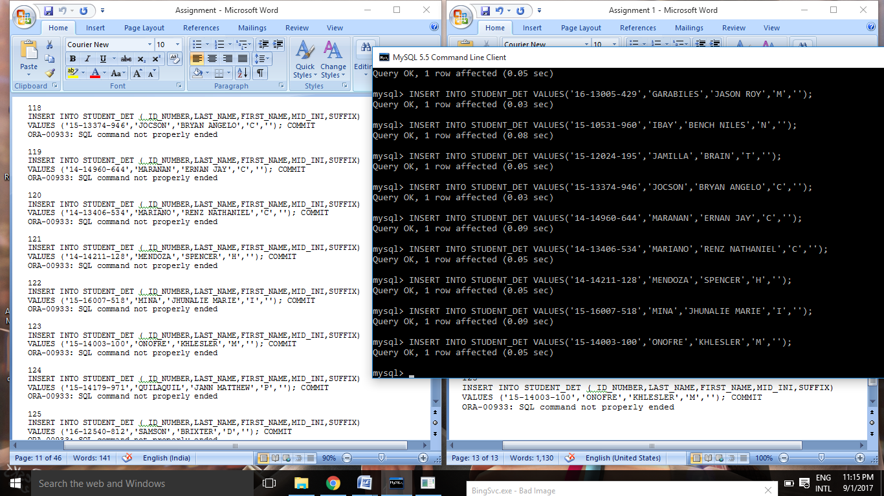

124

INSERT INTO STUDENT_DET ( ID_NUMBER,LAST_NAME,FIRST_NAME,MID_INI,SUFFIX) VALUES ('15-14179-971','QUILAQUIL','JANN MATTHEW','P',''); COMMIT

ORA-00933: SQL command not properly ended

125

INSERT INTO STUDENT_DET ( ID_NUMBER,LAST_NAME,FIRST_NAME,MID_INI,SUFFIX) VALUES ('16-12540-812','SAMSON','BRIXTER','D',''); COMMIT

ORA-00933: SQL command not properly ended

126

INSERT INTO STUDENT_DET ( ID_NUMBER,LAST_NAME,FIRST_NAME,MID_INI,SUFFIX) VALUES ('15-11499-378','SANVICTORES','JOHN PAUL','C',''); COMMIT

ORA-00933: SQL command not properly ended

127

INSERT INTO STUDENT_DET ( ID_NUMBER,LAST_NAME,FIRST_NAME,MID_INI,SUFFIX) VALUES ('16-12410-535','SENTENO','VICTOR','N',''); COMMIT

ORA-00933: SQL command not properly ended

128

INSERT INTO STUDENT_DET ( ID_NUMBER,LAST_NAME,FIRST_NAME,MID_INI,SUFFIX) VALUES ('14-14912-772','TANGLAO','JEFFREY','M','JR'); COMMIT

ORA-00933: SQL command not properly ended

129

INSERT INTO STUDENT_DET ( ID_NUMBER,LAST_NAME,FIRST_NAME,MID_INI,SUFFIX) VALUES ('14-10870-909','TIBON','CHARISSE JHACIELYN','C',''); COMMIT

ORA-00933: SQL command not properly ended

130

INSERT INTO STUDENT_DET ( ID_NUMBER,LAST_NAME,FIRST_NAME,MID_INI,SUFFIX) VALUES ('14-11565-570','TOLENTINO','EDGAR','B','JR.'); COMMIT

ORA-00933: SQL command not properly ended

131

INSERT INTO STUDENT_DET ( ID_NUMBER,LAST_NAME,FIRST_NAME,MID_INI,SUFFIX) VALUES ('15-15397-905','TORRES','MARC NATHANIEL','S',''); COMMIT

ORA-00933: SQL command not properly ended

The Answers:

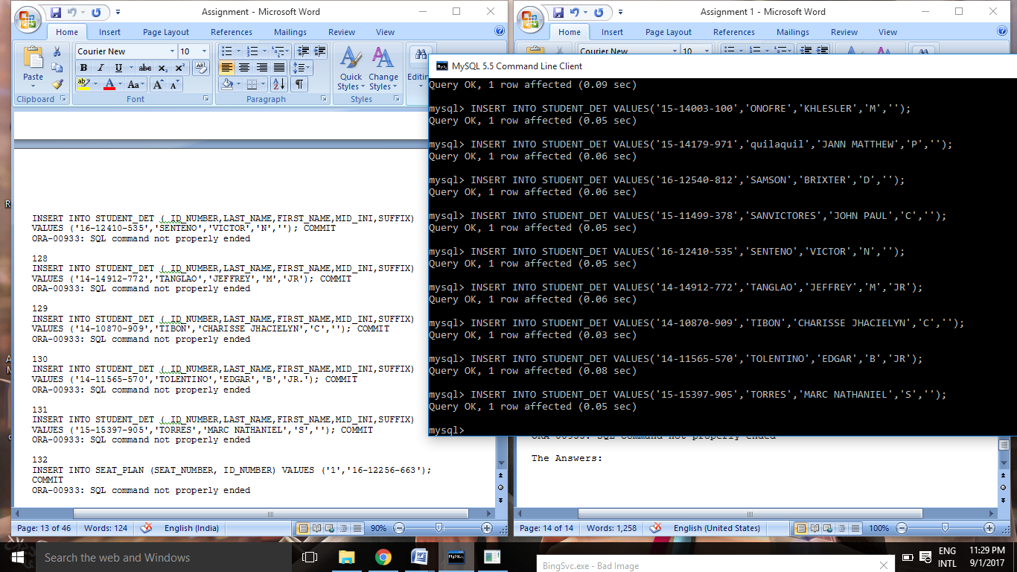

132

INSERT INTO SEAT_PLAN (SEAT_NUMBER, ID_NUMBER) VALUES ('1','16-12256-663'); COMMIT

ORA-00933: SQL command not properly ended

133

INSERT INTO SEAT_PLAN (SEAT_NUMBER, ID_NUMBER) VALUES ('2','14-15630-227'); COMMIT

ORA-00933: SQL command not properly ended

134

INSERT INTO SEAT_PLAN (SEAT_NUMBER, ID_NUMBER) VALUES ('3','15-12315-885'); COMMIT

ORA-00933: SQL command not properly ended

135

INSERT INTO SEAT_PLAN (SEAT_NUMBER, ID_NUMBER) VALUES ('4','15-13846-963'); COMMIT

ORA-00933: SQL command not properly ended

136

INSERT INTO SEAT_PLAN (SEAT_NUMBER, ID_NUMBER) VALUES ('5','14-15194-524'); COMMIT

ORA-00933: SQL command not properly ended

137

INSERT INTO SEAT_PLAN (SEAT_NUMBER, ID_NUMBER) VALUES ('6','1312405'); COMMIT

ORA-00933: SQL command not properly ended

138

INSERT INTO SEAT_PLAN (SEAT_NUMBER, ID_NUMBER) VALUES ('7','16-13787-292'); COMMIT

ORA-00933: SQL command not properly ended

139

INSERT INTO SEAT_PLAN (SEAT_NUMBER, ID_NUMBER) VALUES ('8','14-11840-747'); COMMIT

ORA-00933: SQL command not properly ended

140

INSERT INTO SEAT_PLAN (SEAT_NUMBER, ID_NUMBER) VALUES ('9','15-15994-487'); COMMIT

ORA-00933: SQL command not properly ended

141

INSERT INTO SEAT_PLAN (SEAT_NUMBER, ID_NUMBER) VALUES ('10','14-13152-704'); COMMIT

ORA-00933: SQL command not properly ended

The Answers:

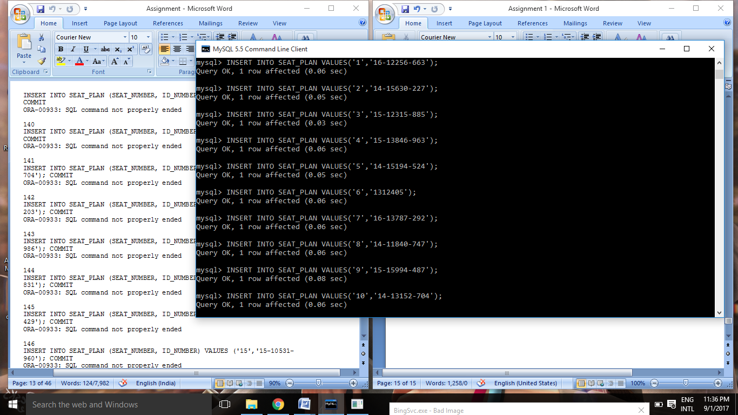

142

INSERT INTO SEAT_PLAN (SEAT_NUMBER, ID_NUMBER) VALUES ('11','14-11432-203'); COMMIT

ORA-00933: SQL command not properly ended

143

INSERT INTO SEAT_PLAN (SEAT_NUMBER, ID_NUMBER) VALUES ('12','14-14069-986'); COMMIT

ORA-00933: SQL command not properly ended

144

INSERT INTO SEAT_PLAN (SEAT_NUMBER, ID_NUMBER) VALUES ('13','16-12720-831'); COMMIT

ORA-00933: SQL command not properly ended

145

INSERT INTO SEAT_PLAN (SEAT_NUMBER, ID_NUMBER) VALUES ('14','16-13005-429'); COMMIT

ORA-00933: SQL command not properly ended

146

INSERT INTO SEAT_PLAN (SEAT_NUMBER, ID_NUMBER) VALUES ('15','15-10531-960'); COMMIT

ORA-00933: SQL command not properly ended

147

INSERT INTO SEAT_PLAN (SEAT_NUMBER, ID_NUMBER) VALUES ('16','15-12024-195'); COMMIT

ORA-00933: SQL command not properly ended

148

INSERT INTO SEAT_PLAN (SEAT_NUMBER, ID_NUMBER) VALUES ('17','15-13374-946'); COMMIT

ORA-00933: SQL command not properly ended

149

INSERT INTO SEAT_PLAN (SEAT_NUMBER, ID_NUMBER) VALUES ('18','14-14960-644'); COMMIT

ORA-00933: SQL command not properly ended

150

INSERT INTO SEAT_PLAN (SEAT_NUMBER, ID_NUMBER) VALUES ('19','14-13406-534'); COMMIT

ORA-00933: SQL command not properly ended

151

INSERT INTO SEAT_PLAN (SEAT_NUMBER, ID_NUMBER) VALUES ('20','14-14211-128'); COMMIT

ORA-00933: SQL command not properly ended

The Answers:

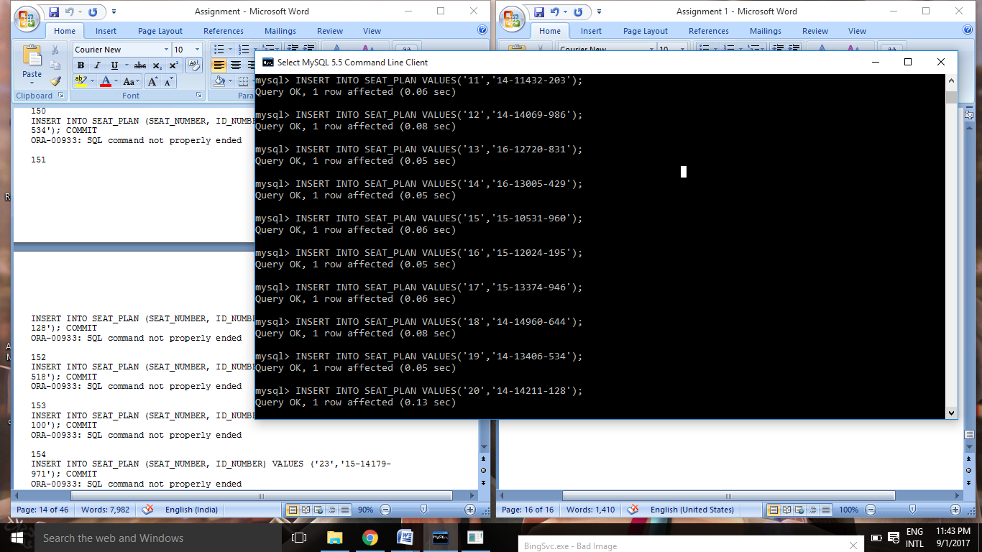

152

INSERT INTO SEAT_PLAN (SEAT_NUMBER, ID_NUMBER) VALUES ('21','15-16007-518'); COMMIT

ORA-00933: SQL command not properly ended

153

INSERT INTO SEAT_PLAN (SEAT_NUMBER, ID_NUMBER) VALUES ('22','15-14003-100'); COMMIT

ORA-00933: SQL command not properly ended

154

INSERT INTO SEAT_PLAN (SEAT_NUMBER, ID_NUMBER) VALUES ('23','15-14179-971'); COMMIT

ORA-00933: SQL command not properly ended

155

INSERT INTO SEAT_PLAN (SEAT_NUMBER, ID_NUMBER) VALUES ('24','16-12540-812'); COMMIT

ORA-00933: SQL command not properly ended

156

INSERT INTO SEAT_PLAN (SEAT_NUMBER, ID_NUMBER) VALUES ('25','15-11499-378'); COMMIT

ORA-00933: SQL command not properly ended

157

INSERT INTO SEAT_PLAN (SEAT_NUMBER, ID_NUMBER) VALUES ('26','16-12410-535'); COMMIT

ORA-00933: SQL command not properly ended

158

INSERT INTO SEAT_PLAN (SEAT_NUMBER, ID_NUMBER) VALUES ('27','14-14912-772'); COMMIT

ORA-00933: SQL command not properly ended

159

INSERT INTO SEAT_PLAN (SEAT_NUMBER, ID_NUMBER) VALUES ('28','14-10870-909'); COMMIT

ORA-00933: SQL command not properly ended

160

INSERT INTO SEAT_PLAN (SEAT_NUMBER, ID_NUMBER) VALUES ('29','14-11565-570'); COMMIT

ORA-00933: SQL command not properly ended

161

INSERT INTO SEAT_PLAN (SEAT_NUMBER, ID_NUMBER) VALUES ('30','15-15397-905'); COMMIT

ORA-00933: SQL command not properly ended

The Answers:

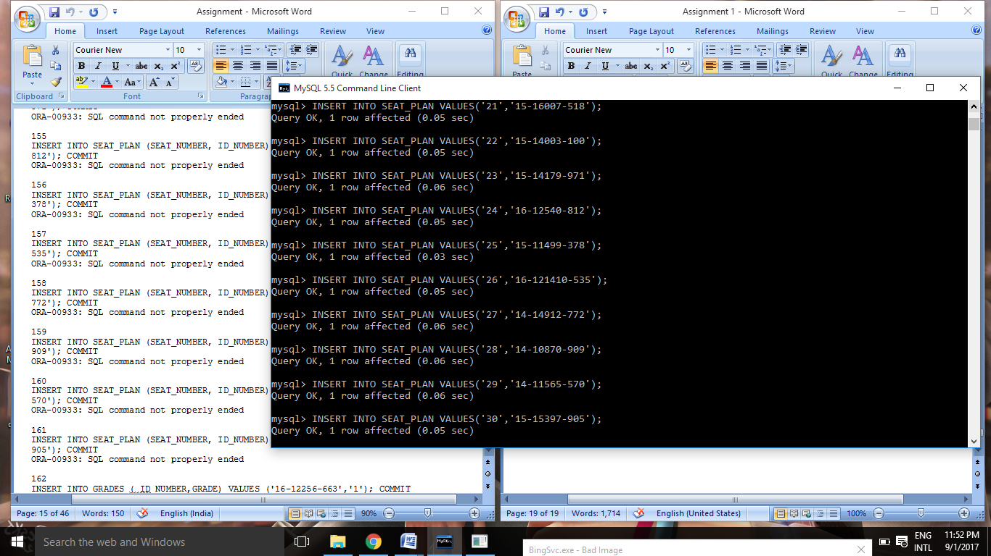

162

INSERT INTO GRADES ( ID_NUMBER,GRADE) VALUES ('16-12256-663','1'); COMMIT

ORA-00933: SQL command not properly ended

163

INSERT INTO GRADES ( ID_NUMBER,GRADE) VALUES ('14-15630-227','1.5'); COMMIT

ORA-00933: SQL command not properly ended

164

INSERT INTO GRADES ( ID_NUMBER,GRADE) VALUES ('15-12315-885','1'); COMMIT

ORA-00933: SQL command not properly ended

165

INSERT INTO GRADES ( ID_NUMBER,GRADE) VALUES ('15-13846-963','1'); COMMIT

ORA-00933: SQL command not properly ended

166

INSERT INTO GRADES ( ID_NUMBER,GRADE) VALUES ('14-15194-524','2'); COMMIT

ORA-00933: SQL command not properly ended

167

INSERT INTO GRADES ( ID_NUMBER,GRADE) VALUES ('1312405','1.5'); COMMIT

ORA-00933: SQL command not properly ended

168

INSERT INTO GRADES ( ID_NUMBER,GRADE) VALUES ('16-13787-292','1.25'); COMMIT

ORA-00933: SQL command not properly ended

169

INSERT INTO GRADES ( ID_NUMBER,GRADE) VALUES ('14-11840-747',''); COMMIT

ORA-00933: SQL command not properly ended

170

INSERT INTO GRADES ( ID_NUMBER,GRADE) VALUES ('15-15994-487','1'); COMMIT

ORA-00933: SQL command not properly ended

171

INSERT INTO GRADES ( ID_NUMBER,GRADE) VALUES ('14-13152-704','2'); COMMIT

ORA-00933: SQL command not properly ended

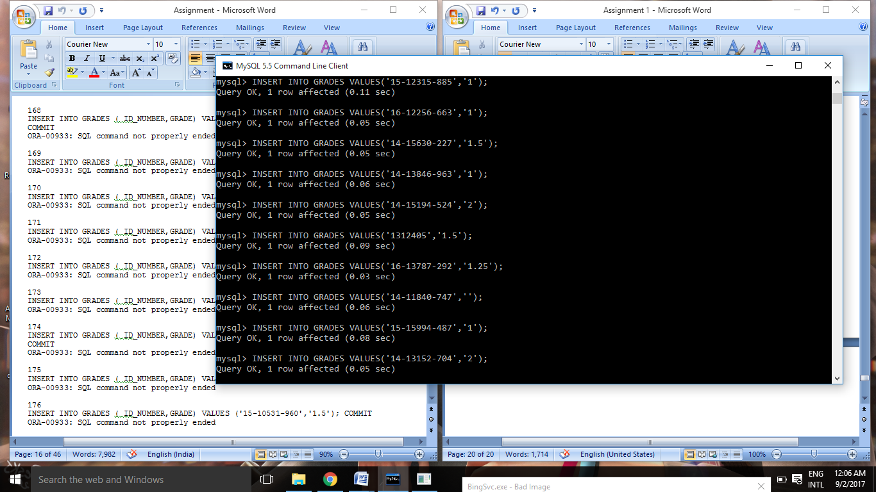

172

INSERT INTO GRADES ( ID_NUMBER,GRADE) VALUES ('14-11432-203','3'); COMMIT

ORA-00933: SQL command not properly ended

173

INSERT INTO GRADES ( ID_NUMBER,GRADE) VALUES ('14-14069-986','2'); COMMIT

ORA-00933: SQL command not properly ended

174

INSERT INTO GRADES ( ID_NUMBER,GRADE) VALUES ('16-12720-831','2.25'); COMMIT

ORA-00933: SQL command not properly ended

175

INSERT INTO GRADES ( ID_NUMBER,GRADE) VALUES ('16-13005-429','1'); COMMIT

ORA-00933: SQL command not properly ended

176

INSERT INTO GRADES ( ID_NUMBER,GRADE) VALUES ('15-10531-960','1.5'); COMMIT

ORA-00933: SQL command not properly ended

177

INSERT INTO GRADES ( ID_NUMBER,GRADE) VALUES ('15-12024-195','1'); COMMIT

ORA-00933: SQL command not properly ended

178

INSERT INTO GRADES ( ID_NUMBER,GRADE) VALUES ('15-13374-946','1'); COMMIT

ORA-00933: SQL command not properly ended

179

INSERT INTO GRADES ( ID_NUMBER,GRADE) VALUES ('14-14960-644','2'); COMMIT

ORA-00933: SQL command not properly ended

180

INSERT INTO GRADES ( ID_NUMBER,GRADE) VALUES ('14-13406-534','1.5'); COMMIT

ORA-00933: SQL command not properly ended

181

INSERT INTO GRADES ( ID_NUMBER,GRADE) VALUES ('14-14211-128','1.25'); COMMIT

ORA-00933: SQL command not properly ended

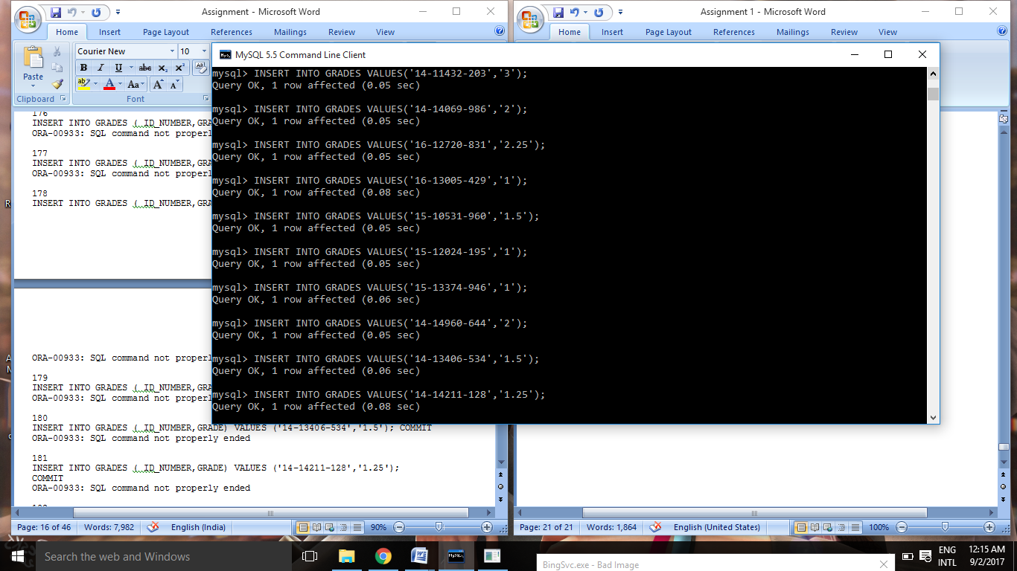

182

INSERT INTO GRADES ( ID_NUMBER,GRADE) VALUES ('15-16007-518',''); COMMIT

ORA-00933: SQL command not properly ended

183

INSERT INTO GRADES ( ID_NUMBER,GRADE) VALUES ('15-14003-100','1'); COMMIT

ORA-00933: SQL command not properly ended

184

INSERT INTO GRADES ( ID_NUMBER,GRADE) VALUES ('15-14179-971','2'); COMMIT

ORA-00933: SQL command not properly ended

185

INSERT INTO GRADES ( ID_NUMBER,GRADE) VALUES ('16-12540-812','3'); COMMIT

ORA-00933: SQL command not properly ended

186

INSERT INTO GRADES ( ID_NUMBER,GRADE) VALUES ('15-11499-378','2'); COMMIT

ORA-00933: SQL command not properly ended

187

INSERT INTO GRADES ( ID_NUMBER,GRADE) VALUES ('16-12410-535','2.25'); COMMIT

ORA-00933: SQL command not properly ended

188

INSERT INTO GRADES ( ID_NUMBER,GRADE) VALUES ('14-14912-772','1'); COMMIT

ORA-00933: SQL command not properly ended

189

INSERT INTO GRADES ( ID_NUMBER,GRADE) VALUES ('14-10870-909','1.5'); COMMIT

ORA-00933: SQL command not properly ended

190

INSERT INTO GRADES ( ID_NUMBER,GRADE) VALUES ('14-11565-570','1'); COMMIT

ORA-00933: SQL command not properly ended

191

INSERT INTO GRADES ( ID_NUMBER,GRADE) VALUES ('15-15397-905','1'); COMMIT

ORA-00933: SQL command not properly ended

**The Answers:**

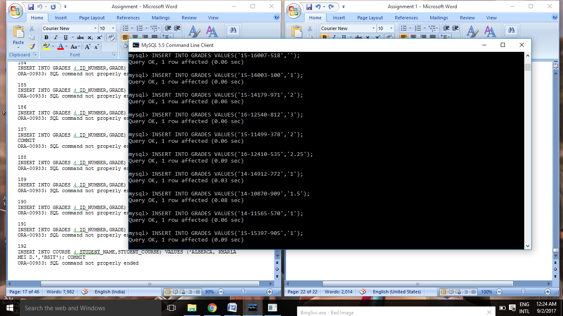

**Modification for Course table:**

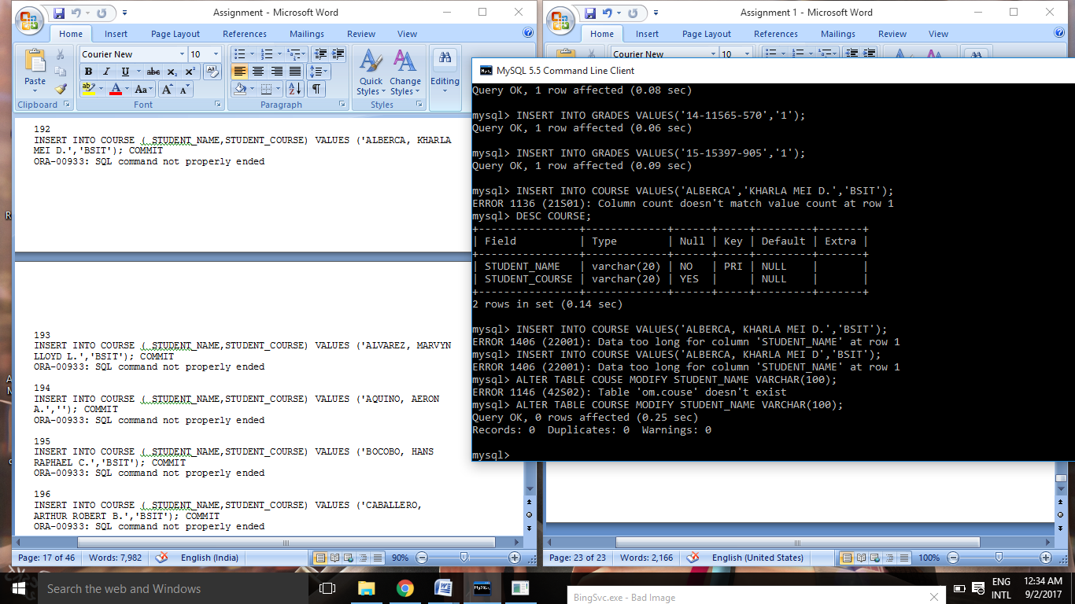

192

INSERT INTO COURSE ( STUDENT_NAME,STUDENT_COURSE) VALUES ('ALBERCA, KHARLA MEI D.','BSIT'); COMMIT

ORA-00933: SQL command not properly ended

193

INSERT INTO COURSE ( STUDENT_NAME,STUDENT_COURSE) VALUES ('ALVAREZ, MARVYN LLOYD L.','BSIT'); COMMIT

ORA-00933: SQL command not properly ended

194

INSERT INTO COURSE ( STUDENT_NAME,STUDENT_COURSE) VALUES ('AQUINO, AERON A.',''); COMMIT

ORA-00933: SQL command not properly ended

195

INSERT INTO COURSE ( STUDENT_NAME,STUDENT_COURSE) VALUES ('BOCOBO, HANS RAPHAEL C.','BSIT'); COMMIT

ORA-00933: SQL command not properly ended

196

INSERT INTO COURSE ( STUDENT_NAME,STUDENT_COURSE) VALUES ('CABALLERO, ARTHUR ROBERT B.','BSIT'); COMMIT

ORA-00933: SQL command not properly ended

197

INSERT INTO COURSE ( STUDENT_NAME,STUDENT_COURSE) VALUES ('CAMPOS, JEFFERSON C.','BSIT'); COMMIT

ORA-00933: SQL command not properly ended

198

INSERT INTO COURSE ( STUDENT_NAME,STUDENT_COURSE) VALUES ('CARMESIS, ADRIAN B.','BSIT'); COMMIT

ORA-00933: SQL command not properly ended

199

INSERT INTO COURSE ( STUDENT_NAME,STUDENT_COURSE) VALUES ('COMETA, MARIA LOURDES E.','BSIT'); COMMIT

ORA-00933: SQL command not properly ended

200

INSERT INTO COURSE ( STUDENT_NAME,STUDENT_COURSE) VALUES ('DELA PEÑA, JEG D.','BSIT'); COMMIT

ORA-00933: SQL command not properly ended

201

INSERT INTO COURSE ( STUDENT_NAME,STUDENT_COURSE) VALUES ('DUCANES, MARK JOSEPH B.','BSIT'); COMMIT

ORA-00933: SQL command not properly ended

The Answers:

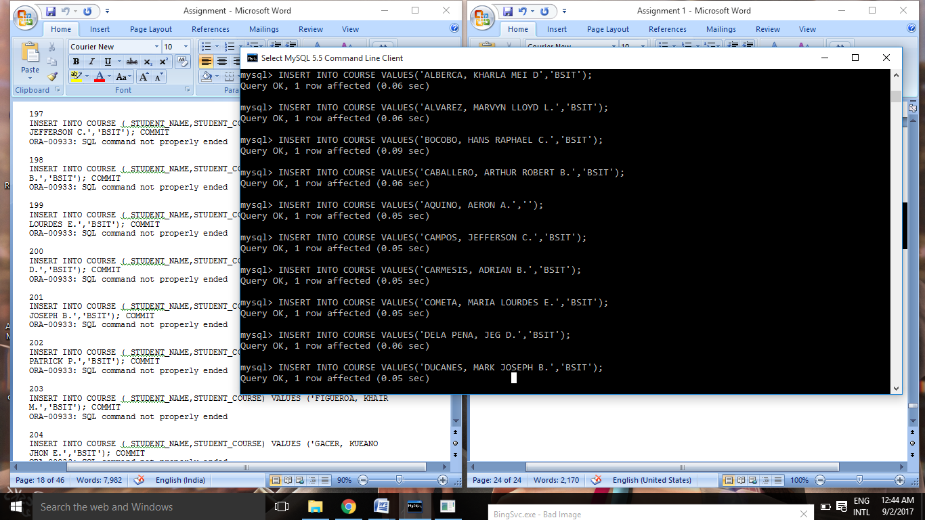

202

INSERT INTO COURSE ( STUDENT_NAME,STUDENT_COURSE) VALUES ('EDELEON, NEIL PATRICK P.','BSIT'); COMMIT

ORA-00933: SQL command not properly ended

203

INSERT INTO COURSE ( STUDENT_NAME,STUDENT_COURSE) VALUES ('FIGUEROA, KHAIR M.','BSIT'); COMMIT

ORA-00933: SQL command not properly ended

204

INSERT INTO COURSE ( STUDENT_NAME,STUDENT_COURSE) VALUES ('GACER, KUEANO JHON E.','BSIT'); COMMIT

ORA-00933: SQL command not properly ended

205

INSERT INTO COURSE ( STUDENT_NAME,STUDENT_COURSE) VALUES ('GARABILES, JASON ROY M.','BSIT'); COMMIT

ORA-00933: SQL command not properly ended

206

INSERT INTO COURSE ( STUDENT_NAME,STUDENT_COURSE) VALUES ('IBAY, BENCH NILES N.','BSIT'); COMMIT

ORA-00933: SQL command not properly ended

207

INSERT INTO COURSE ( STUDENT_NAME,STUDENT_COURSE) VALUES ('JAMILLA, BRIAN T.','BSIT'); COMMIT

ORA-00933: SQL command not properly ended

208

INSERT INTO COURSE ( STUDENT_NAME,STUDENT_COURSE) VALUES ('JOCSON, BRYAN ANGELO C.','BSIT'); COMMIT

ORA-00933: SQL command not properly ended

209

INSERT INTO COURSE ( STUDENT_NAME,STUDENT_COURSE) VALUES ('MARANAN, ERNAN JAY C.','BSIT'); COMMIT

ORA-00933: SQL command not properly ended

210

INSERT INTO COURSE ( STUDENT_NAME,STUDENT_COURSE) VALUES ('MARIANO, RENZ NATHANIEL C.','BSIT'); COMMIT

ORA-00933: SQL command not properly ended

211

INSERT INTO COURSE ( STUDENT_NAME,STUDENT_COURSE) VALUES ('MENDOZA, SPENCER H.','BSIT'); COMMIT

ORA-00933: SQL command not properly ended

**The Answers:**

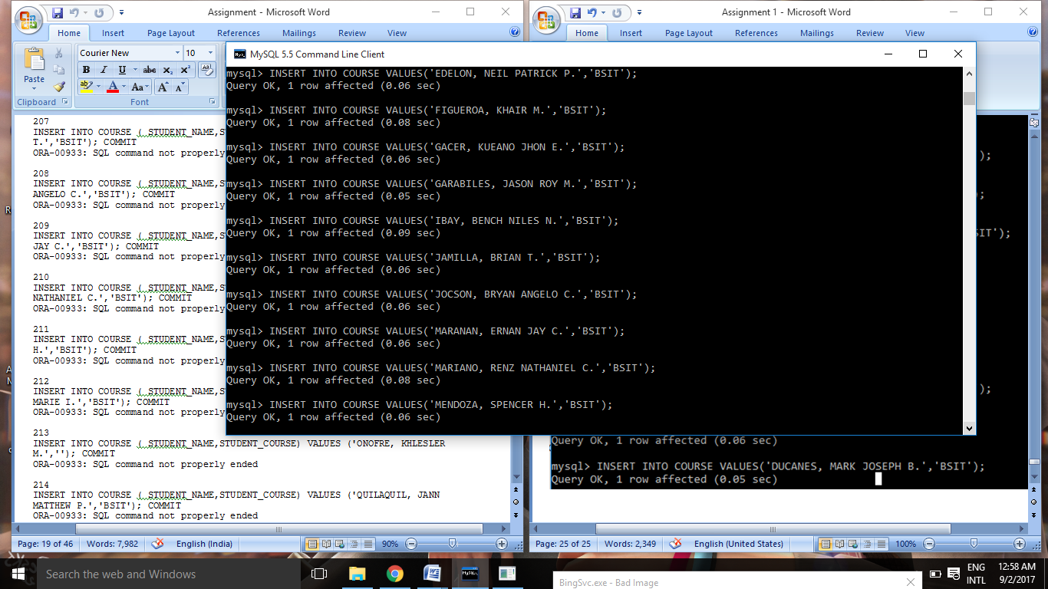

212

INSERT INTO COURSE ( STUDENT_NAME,STUDENT_COURSE) VALUES ('MINA, JHUNALIE MARIE I.','BSIT'); COMMIT

ORA-00933: SQL command not properly ended

213

INSERT INTO COURSE ( STUDENT_NAME,STUDENT_COURSE) VALUES ('ONOFRE, KHLESLER M.',''); COMMIT

ORA-00933: SQL command not properly ended

214

INSERT INTO COURSE ( STUDENT_NAME,STUDENT_COURSE) VALUES ('QUILAQUIL, JANN MATTHEW P.','BSIT'); COMMIT

ORA-00933: SQL command not properly ended

215

INSERT INTO COURSE ( STUDENT_NAME,STUDENT_COURSE) VALUES ('SAMSON, BRIXTER D.','BSIT'); COMMIT

ORA-00933: SQL command not properly ended

216

INSERT INTO COURSE ( STUDENT_NAME,STUDENT_COURSE) VALUES ('SANVICTORES, JOHN PAUL C.','BSIT'); COMMIT

ORA-00933: SQL command not properly ended

217

INSERT INTO COURSE ( STUDENT_NAME,STUDENT_COURSE) VALUES ('SENTENO, VICTOR N.','BSIT'); COMMIT

ORA-00933: SQL command not properly ended

218

INSERT INTO COURSE ( STUDENT_NAME,STUDENT_COURSE) VALUES ('TANGLAO JR., JEFFREY M.','BSIT'); COMMIT

ORA-00933: SQL command not properly ended

219

INSERT INTO COURSE ( STUDENT_NAME,STUDENT_COURSE) VALUES ('TIBON, CHARISSE JHACIELYN C.',''); COMMIT

ORA-00933: SQL command not properly ended

220

INSERT INTO COURSE ( STUDENT_NAME,STUDENT_COURSE) VALUES ('TOLENTINO, EDGAR, JR. B.','BSIT'); COMMIT

ORA-00933: SQL command not properly ended

221

INSERT INTO COURSE ( STUDENT_NAME,STUDENT_COURSE) VALUES ('TORRES, MARC NATHANIEL S.','BSIT'); COMMIT

ORA-00933: SQL command not properly ended

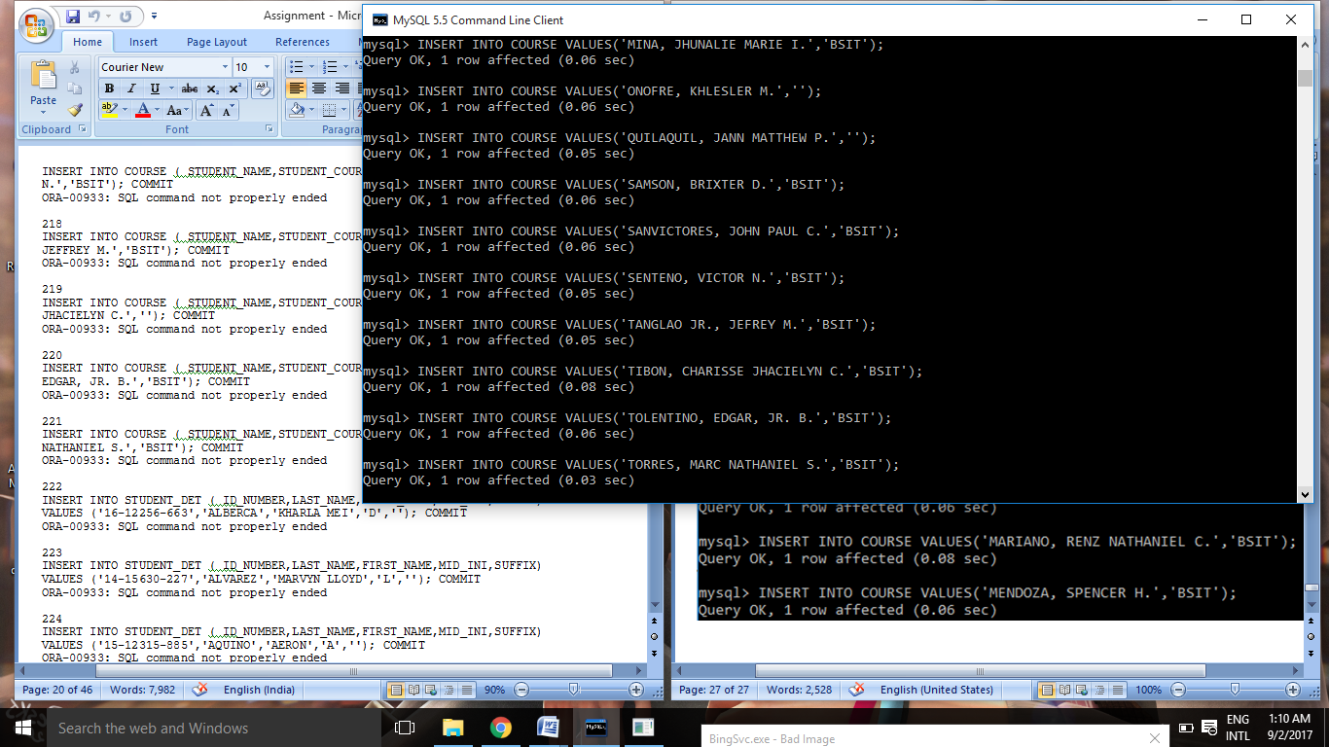

**Questions 222 – 311,408 - 437 about STUDENT_DET( ALL COVERED ABOVE)**

**Questions 322 – 401,438 - 527 about SEAT_PLAN,GRADES,COURSE( ALL COVERED ABOVE)**

528

select * from STUDENT_DET

ID_NUMBER LAST_NAME FIRST_NAME MID_INI SUFFIX

16-12256-663 ALBERCA KHARLA MEI D -

14-15630-227 ALVAREZ MARVYN L -

15-12315-885 AQUINO AERON A -

15-13846-963 BOCOBO HANS RAPHAEL C -

14-15194-524 CABALLERO ARTHUR ROBERT B -

1312405 CAMPOS JEFFERSON C -

16-13787-292 CARMESIS ADRIAN B -

14-11840-747 COMETA MARIA LOURDES E -

15-15994-487 DELA PEÑA JEG D -

14-13152-704 DUCANES MARK JOSEPH B -

14-11432-203 EDELEON NEIL PATRICK P -

14-14069-986 FIGUEROA KHAIR M -

16-12720-831 GACER KUEANO JHON E -

16-13005-429 GARABILES JASON ROY M -

15-10531-960 IBAY BENCH NILES N -

15-12024-195 JAMILLA BRIAN T -

15-13374-946 JOCSON BRYAN ANGELO C -

14-14960-644 MARANAN ERNAN JAY C -

14-14211-128 MENDOZA SPENCER H -

15-16007-518 MINA JHUNALIE MARIE I -

15-14003-100 ONOFRE KHLESLER M -

15-14179-971 QUILAQUIL JANN MATTHEW P -

16-12540-812 SAMSON BRIXTER D -

15-11499-378 SANVICTORES JOHN PAUL C -

16-12410-535 SENTENO VICTOR N -

14-14912-772 TANGLAO JEFFREY M JR

14-10870-909 TIBON CHARISSE JHACIELYN C -

14-11565-570 TOLENTINO EDGAR B JR.

15-15397-905 TORRES MARC NATHANIEL S -

16-12256-663 ALBERCA KHARLA MEI D -

14-15630-227 ALVAREZ MARVYN LLOYD L -

15-12315-885 AQUINO AERON A -

15-13846-963 BOCOBO HANS RAPHAEL C -

14-15194-524 CABALLERO ARTHUR ROBERT B -

1312405 CAMPOS JEFFERSON C -

16-13787-292 CARMESIS ADRIAN B -

14-11840-747 COMETA MARIA LOURDES E -

15-15994-487 DELA PEÑA JEG D -

14-13152-704 DUCANES MARK JOSEPH B -

14-11432-203 EDELEON NEIL PATRICK P -

14-14069-986 FIGUEROA KHAIR M -

16-12720-831 GACER KUEANO JHON E -

16-13005-429 GARABILES JASON ROY M -

15-10531-960 IBAY BENCH NILES N -

15-12024-195 JAMILLA BRIAN T -

15-13374-946 JOCSON BRYAN ANGELO C -

14-14960-644 MARANAN ERNAN JAY C -

14-14211-128 MENDOZA SPENCER H -

15-16007-518 MINA JHUNALIE MARIE I -

15-14003-100 ONOFRE KHLESLER M -

15-14179-971 QUILAQUIL JANN MATTHEW P -

16-12540-812 SAMSON BRIXTER D -

15-11499-378 SANVICTORES JOHN PAUL C -

16-12410-535 SENTENO VICTOR N -

14-14912-772 TANGLAO JEFFREY M JR

14-10870-909 TIBON CHARISSE JHACIELYN C -

14-11565-570 TOLENTINO EDGAR B JR.

15-15397-905 TORRES MARC NATHANIEL S -

58 rows selected.

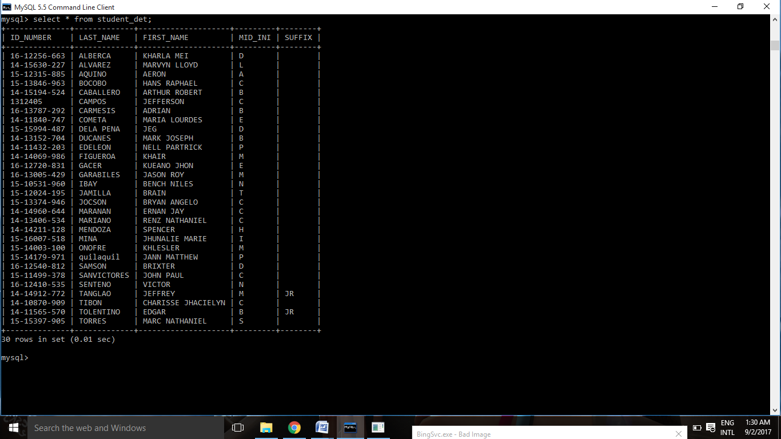

529

select * from GRADES

ID_NUMBER GRADE

16-12256-663 1

14-15630-227 1.5

15-12315-885 1

15-13846-963 1

14-15194-524 2

1312405 1.5

16-13787-292 1.25

14-11840-747 -

15-15994-487 1

14-13152-704 2

14-11432-203 3

14-14069-986 2

16-12720-831 2.25

16-13005-429 1

15-10531-960 1.5

15-12024-195 1

15-13374-946 1

14-14960-644 2

14-13406-534 1.5

14-14211-128 1.25

15-16007-518 -

15-14003-100 1

15-14179-971 2

16-12540-812 3

15-11499-378 2

16-12410-535 2.25

14-14912-772 1

14-10870-909 1.5

14-11565-570 1

15-15397-905 1

30 rows selected.

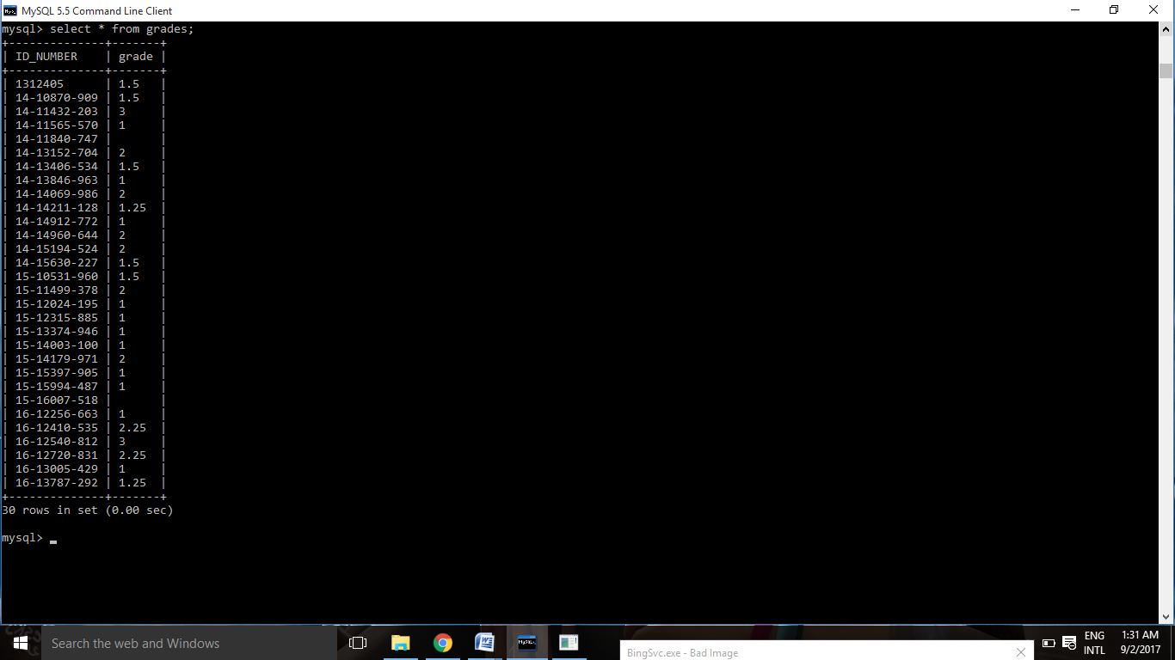

530

select * from COURSE

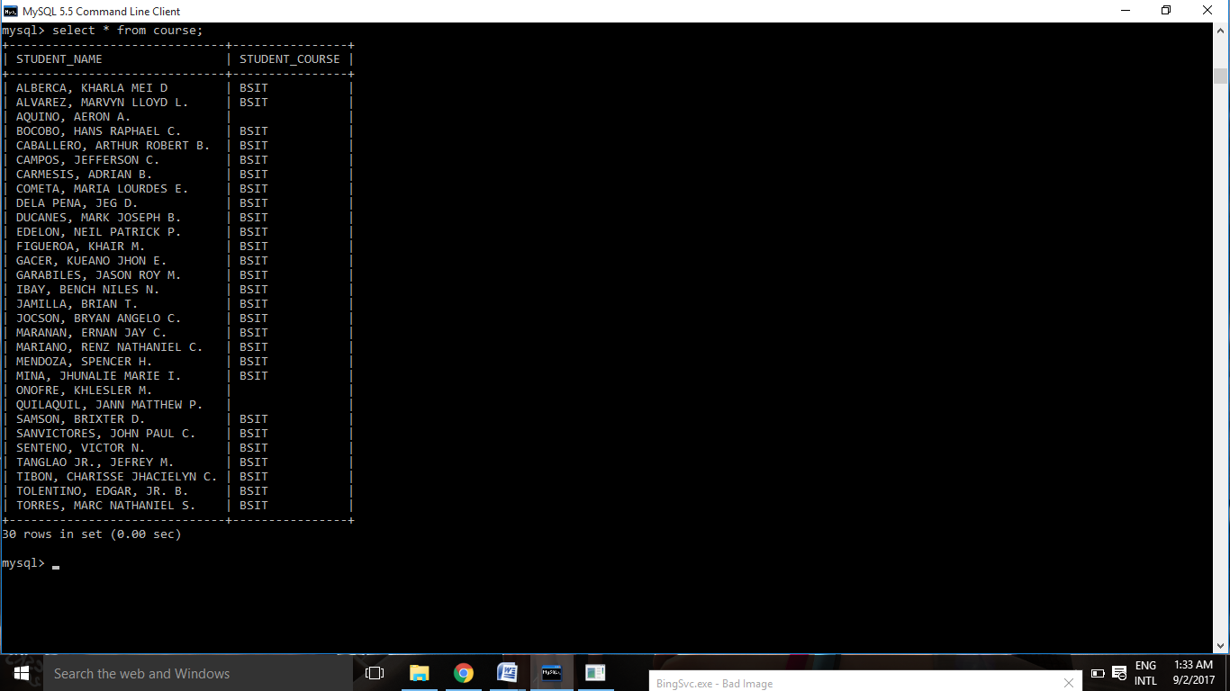

531

Select * from SEAT_PLAN

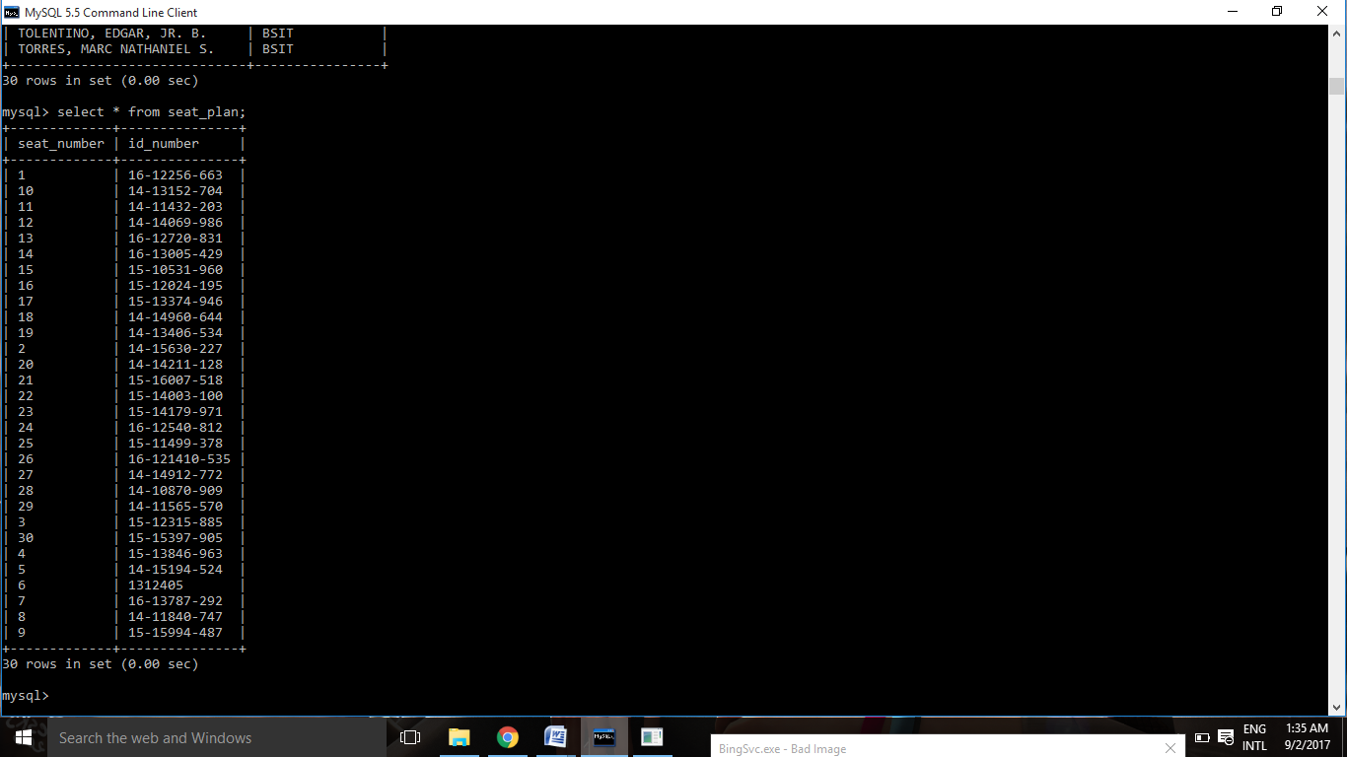

402

drop table SEAT_PLAN

Table dropped.

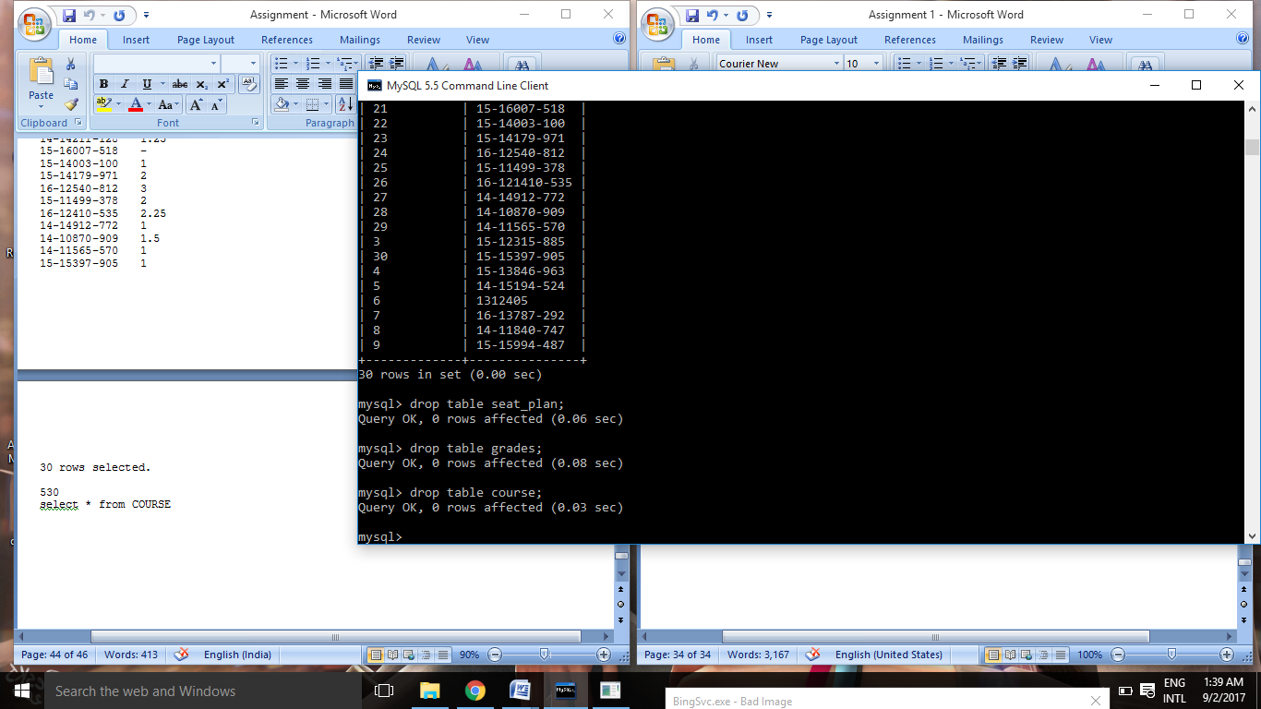

403

drop table GRADES

Table dropped.



404

drop table COURSE

Table dropped.

